**Project Title: Healthcare Follow-up & Preventive Care CRM**

**Phase 1:-** **Problem Understanding & Industry Analysis**

**Problem Statement**

Hospitals and clinics face significant challenges in ensuring patients attend follow-up consultations and participate in preventive healthcare programs such as vaccinations, routine health checkups, and chronic illness monitoring. Manual tracking of patient visits and communication often leads to missed appointments, delayed treatments, and poor patient engagement.

These issues not only affect patient health outcomes but also result in inefficiencies and revenue loss for healthcare providers. There is a growing need for a **centralized CRM solution** that can automate appointment scheduling, send timely reminders, and provide visibility into patient follow-up compliance and preventive care participation.

By implementing a Salesforce-based CRM system, hospitals can:

* Manage patient records efficiently.
* Automate reminders for follow-ups and preventive care.
* Provide doctors and staff with real-time access to treatment history.
* Enable management to monitor performance with dashboards and reports.

**Project Overview**

The proposed solution is a Salesforce-based **Healthcare Follow-up & Preventive Care CRM** designed to help hospitals and clinics improve patient engagement. The system will manage patient records, automate appointment scheduling, and send timely reminders for follow-ups and preventive care programs such as vaccinations, health checkups, and chronic disease monitoring.

**Who will use it?**

* **Doctors & Nurses** → to track patient treatment plans and follow-ups.
* **Hospital Admin Staff** → to schedule appointments, manage records, and analyze reports.
* **Patients** → to receive reminders, check appointments, and stay engaged with preventive care.

**How it will help?**  
This solution ensures that patients do not miss important medical appointments, improves preventive care participation, and reduces manual work for hospital staff. It will provide real-time dashboards to management, helping them monitor patient inflow, follow-up completion rates, and overall hospital efficiency.

**Objectives**

The main goals of the project are:

1. **Improve Efficiency** – Automate appointment scheduling and follow-up reminders.
2. **Automate Manual Tasks** – Reduce manual tracking of patient visits and preventive care programs.
3. **Provide Better Reporting** – Generate dashboards and reports on patient inflow, missed vs. completed follow-ups, and preventive care participation.
4. **Ensure Data Accuracy** – Maintain complete patient medical history and treatment details in one place.
5. **Enhance Patient Experience** – Keep patients engaged through timely notifications, reminders, and easy access to their appointment details.

**Phase 2:- Documentation — Org Setup & Configuration**

## ****1. Salesforce Edition & Dev Org Setup****

We used a **Salesforce Developer Edition Org** to build this project.

* Enabled **My Domain** and deployed successfully.
* Verified login using the new domain.

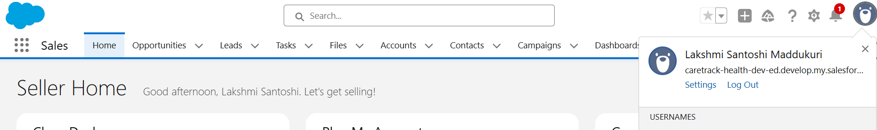

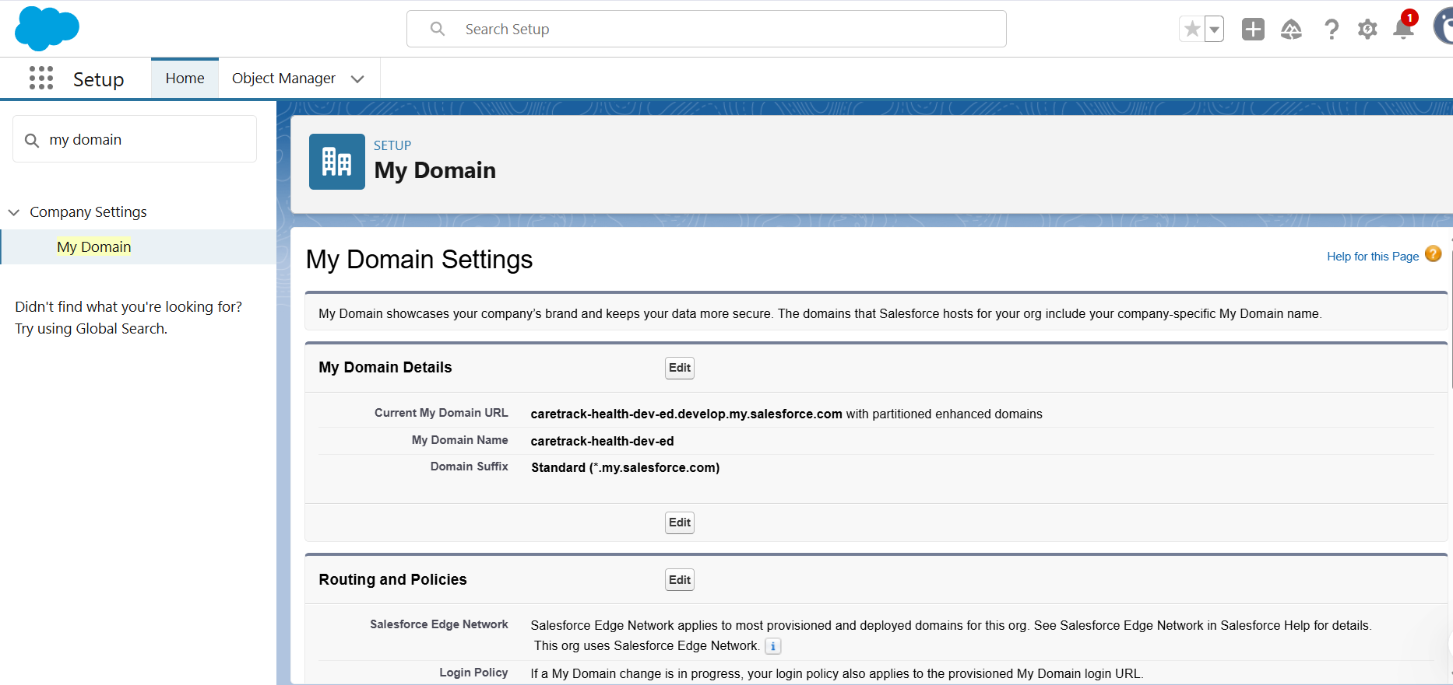

## ****2. Company Profile Setup****

* Company Name: CareTrack Health Pvt Ltd
* Default Time Zone: Asia/Kolkata (IST)
* Fiscal Year: Standard (Jan–Dec)

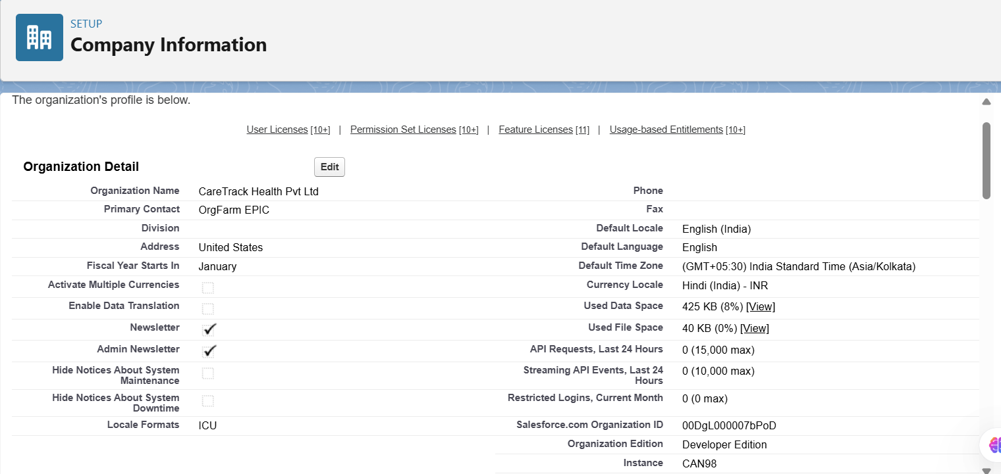

* Business Hours: 9 AM – 6 PM IST, Mon–Sat

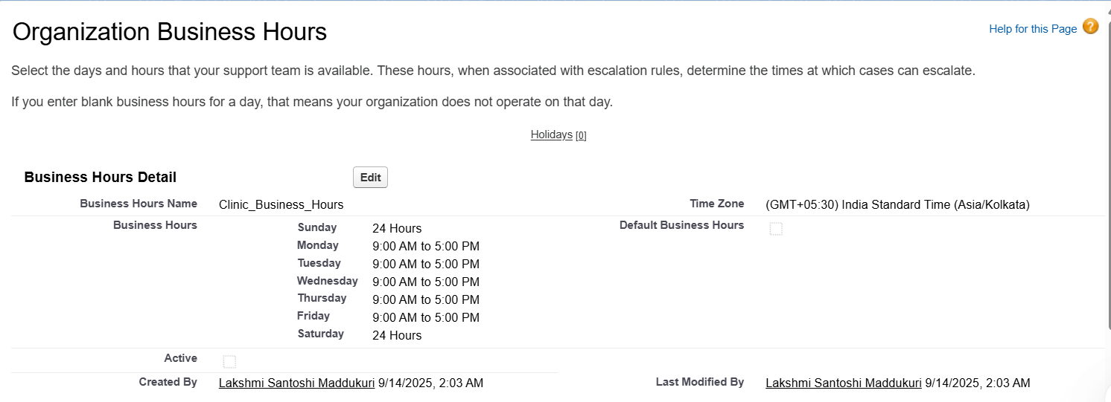

* Holidays Configured: Republic Day, Independence Day

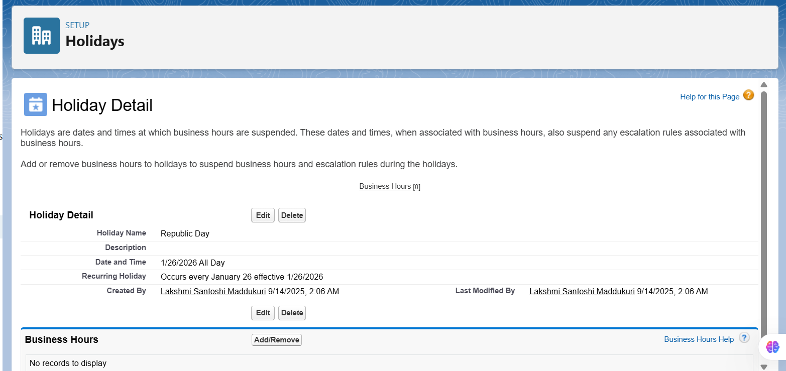

## ****3. Roles (Role Hierarchy)****

We created a role hierarchy to reflect hospital structure:

CEO  
↳ Hospital Admin  
 ↳ Hospital Director  
  ↳ Doctor  
  ↳ Nurse  
  ↳ Receptionist

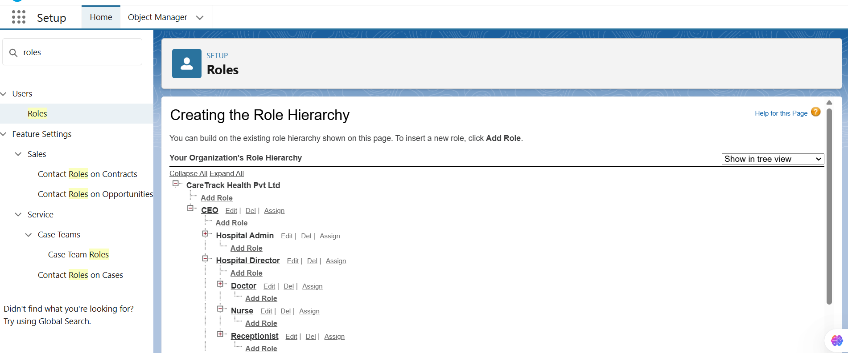

## ****4. Profiles****

Created/Cloned profiles to control object and field-level access.

* **Hospital_Admin_Profile** → cloned from System Administrator.
* **Doctor_Profile** → cloned from Standard User.
* **Nurse_Profile**.
* **Receptionist_Profile**.

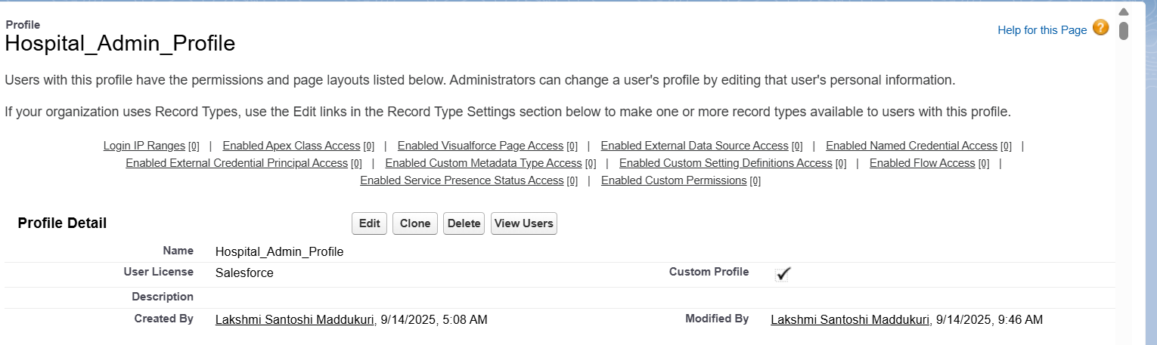

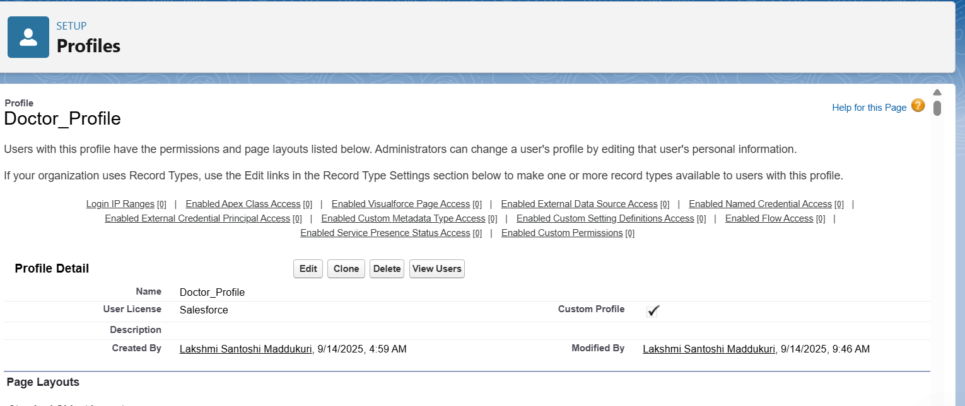

## ****5. Permission Sets****

Created permission sets for additional flexibility:

* **PS_Patient_PII_Access** → Sensitive patient fields (Doctors only).
* **PS_Bulk_Data_Importer** → Planned (will be required for Admin bulk data operations in later phases).
* **PS_Experience_User** → Planned (will be required when enabling the Patient Portal in Phase 6).

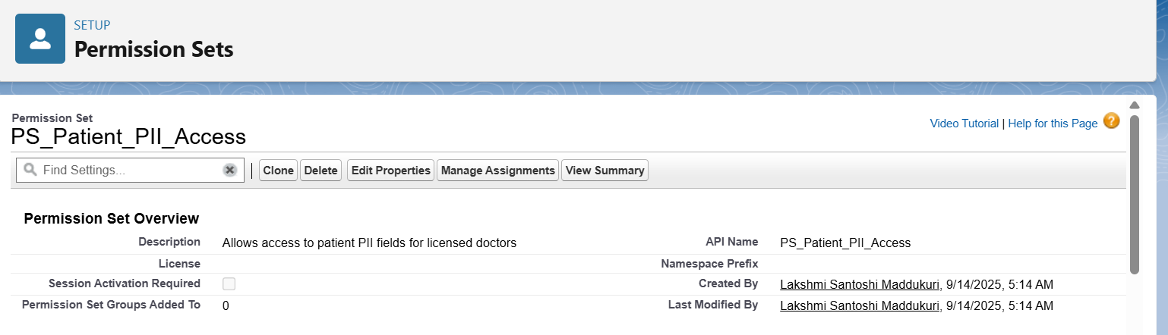

## ****6. Organization-Wide Defaults (OWD)****

Configured strict privacy for medical data.

* Patient__c → Private
* Appointment__c → Controlled by Parent
* Treatment_Plan__c → Controlled by Parent
* FollowUp_Schedule__c → Controlled by Parent

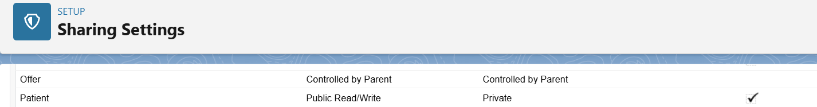



## ****7. Public Groups****

Created groups for sharing rules and collaboration.

* All_Doctors → includes Role: Doctor.
* All_Receptionists → includes Role: Receptionist.
* Care_Management_Team → includes Hospital Admin + Dept Heads.

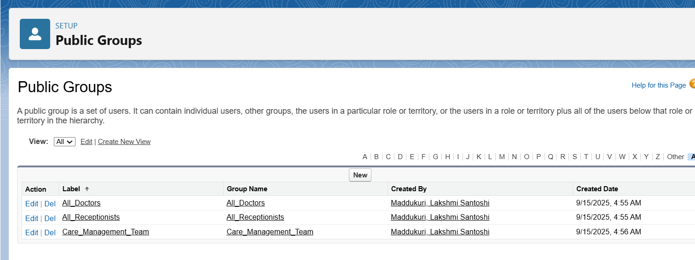

## ****8. Login Access & Security****

Security settings were configured to ensure safe access:

* Session Timeout: 30 minutes idle.
* Multi-Factor Authentication (MFA): Enabled for internal users.
* Login Access Policies: Admin can log in as any user (testing).
* Audit Trail & Login History: Enabled for monitoring.

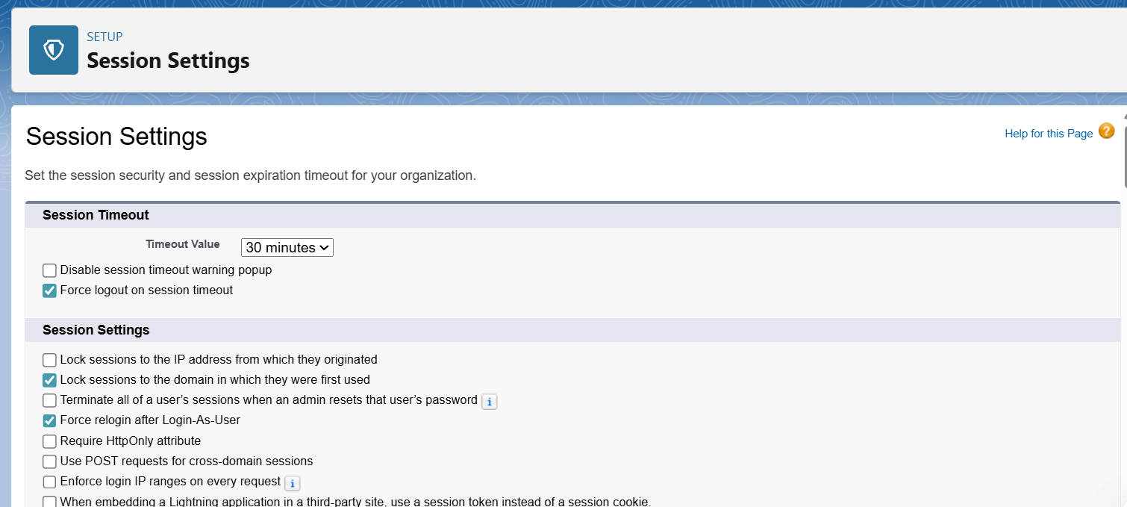

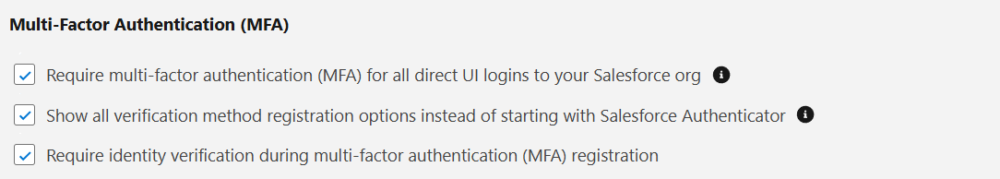

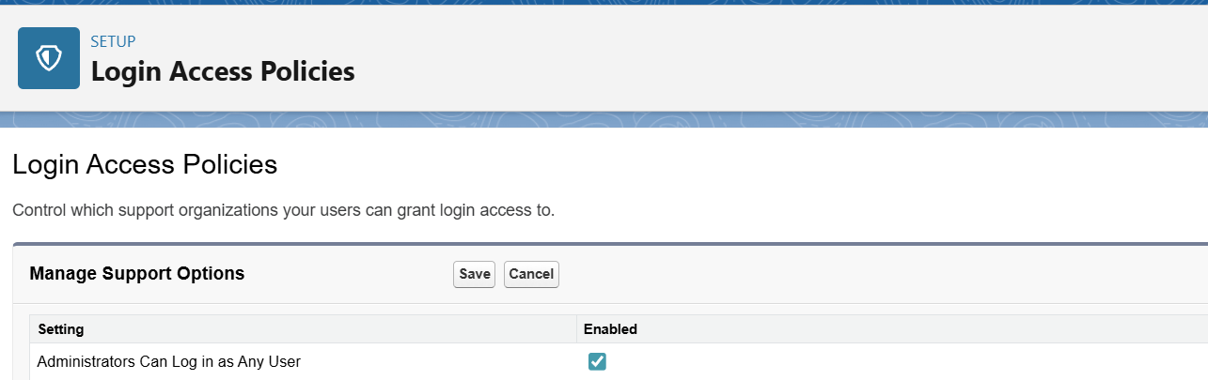

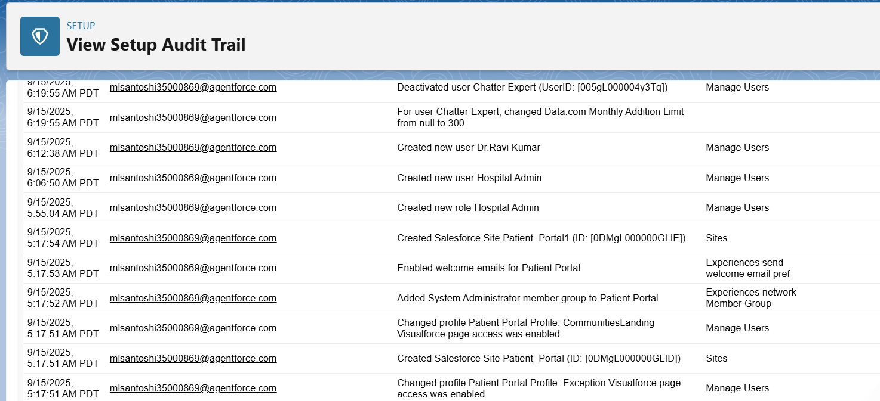

## ****9. Dev Org Setup Specifics****

* My Domain: Enabled & deployed.
* Experience Cloud: Enabled → “Patient Portal” created (Draft).
* API Access: Confirmed for System Administrator profile.

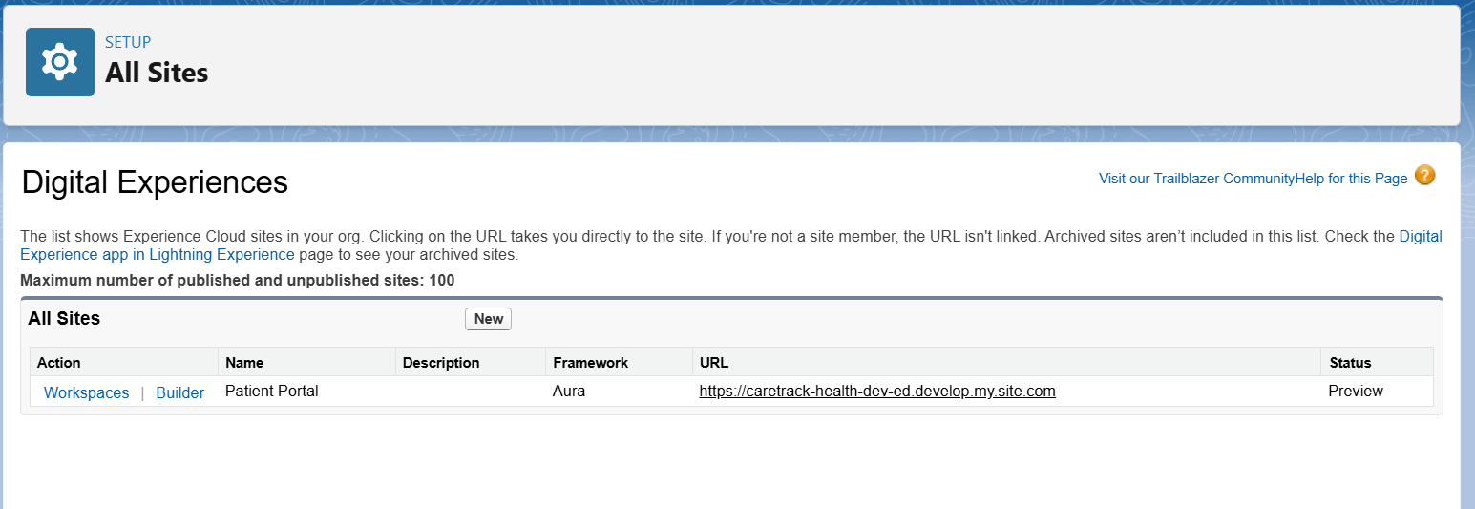

## ****10. Users****

Sample users created for testing:

* Hospital Admin → hospital.admin@caretrack.dev (System Admin).
* Doctor Ravi → dr.ravi@caretrack.dev (Doctor_Profile, Role = Doctor).
* Nurse Anu → Planned (license limitation).
* Receptionist Maya → Planned (license limitation).

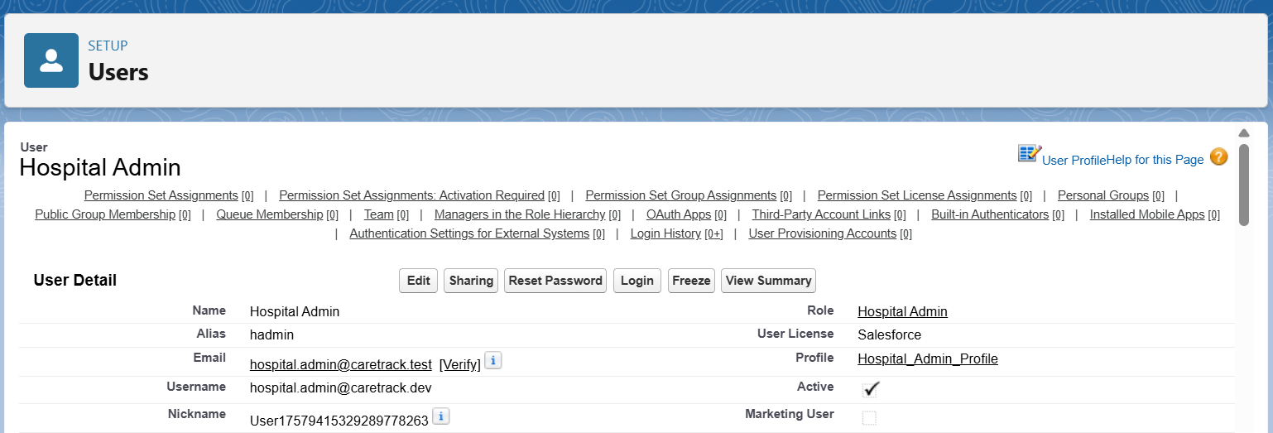

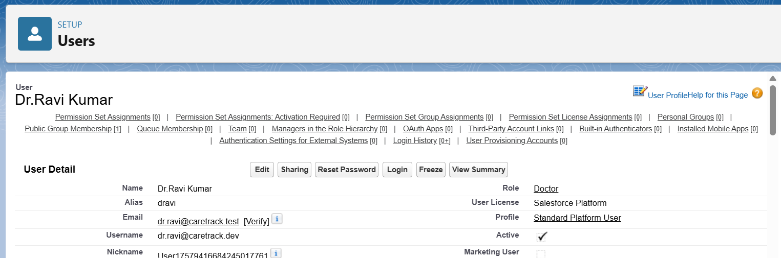

**Phase 3 :- Data Modeling & Relationships**

### 1. Standard & Custom Objects

* Used standard objects: **User** (Doctors, Nurses, Admins).
* Created custom objects:
  + **Patient__c** (master record for patients)
  + **Appointment__c** (linked to Patient)
  + **Treatment_Plan__c** (linked to Patient)
  + **FollowUp_Schedule__c** (linked to Patient)
  + **Clinic_Location__c** (referenced from Appointment)

### 2. Fields

* Added key fields for each object:
  + Patient__c → FirstName, LastName (required), Gender, DOB, Phone, Email, Assigned_Doctor__c (Lookup → User).
  + Appointment__c → Appointment_Date__c, Status__c (Scheduled/Completed/Missed), Clinic_Location__c (Lookup → Clinic_Location__c).
  + Treatment_Plan__c → Diagnosis__c, Medication__c, Next_Review_Date__c.
  + FollowUp_Schedule__c → FollowUp_Date__c, Notes__c.

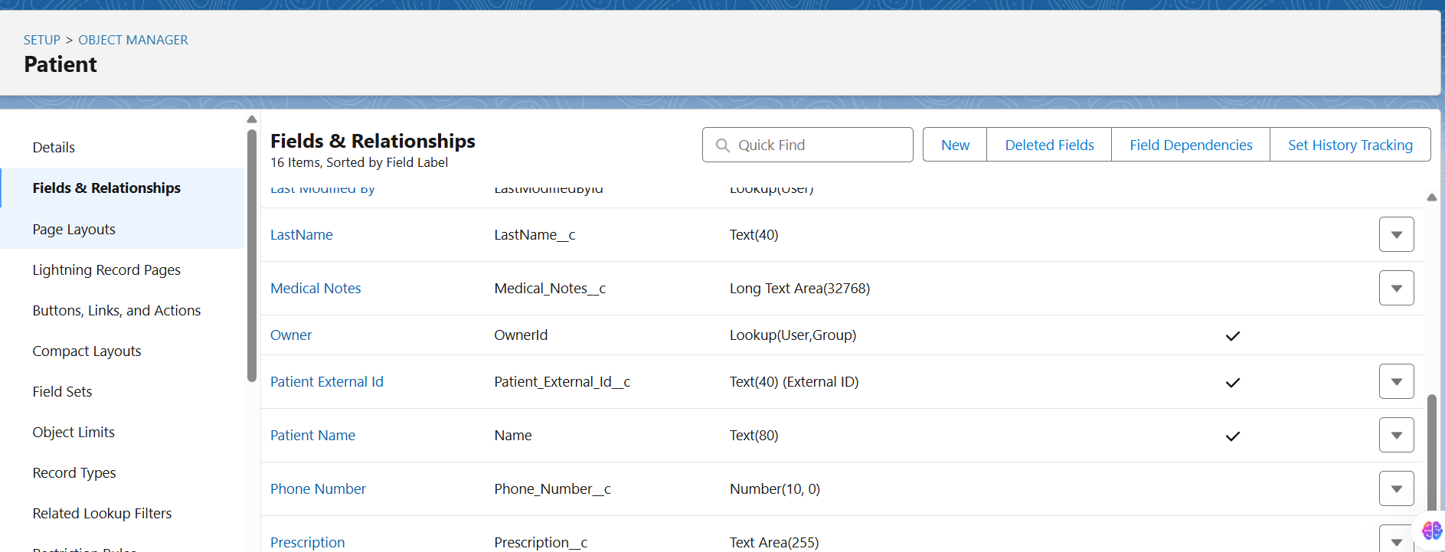

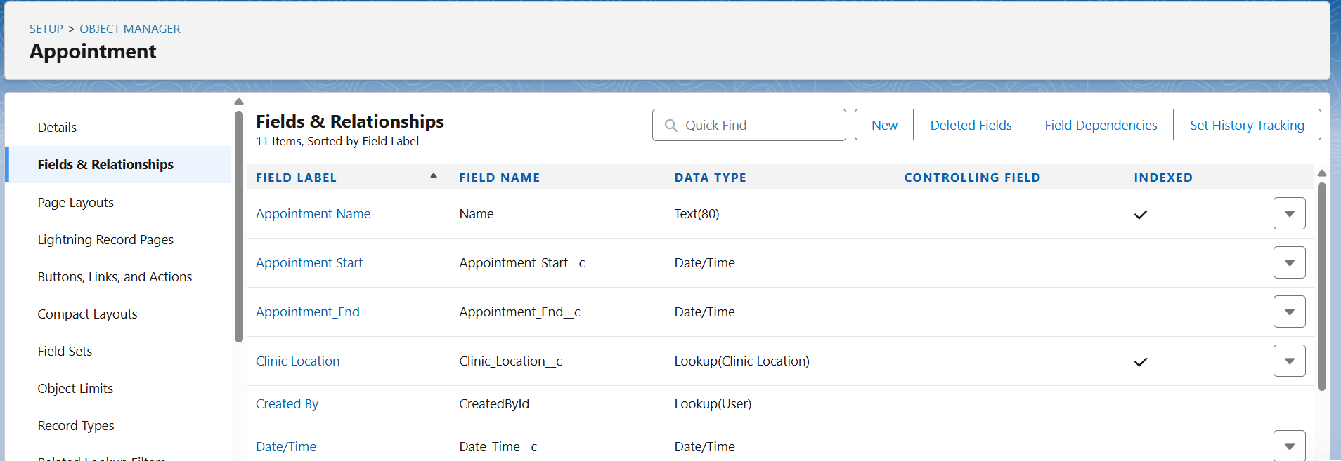

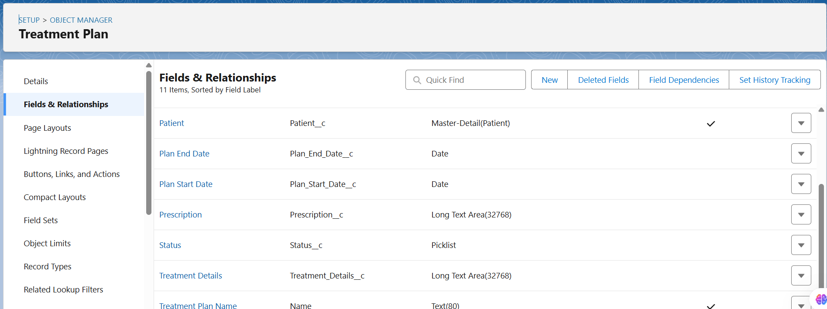

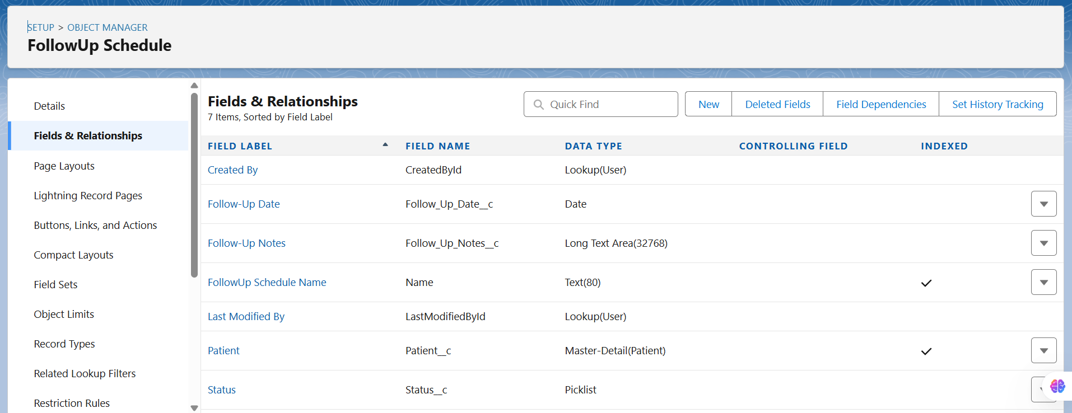

### 3. Record Types

* Created Record Types for **Patient**:
  + Outpatient
  + Inpatient
* Assigned Record Types to profiles:
  + Doctor_Profile → both Outpatient & Inpatient.
  + Receptionist_Profile → Outpatient only.

### 

### 

### 4. Page Layouts

* Created role-based layouts:
  + **Doctor Layout** → includes Medical Details, Appointments, Treatment Plans, FollowUp Schedules.
  + **Nurse Layout** → shows Medical Details but hides sensitive free text fields.
  + **Receptionist Layout** → only Personal Info + Appointments.

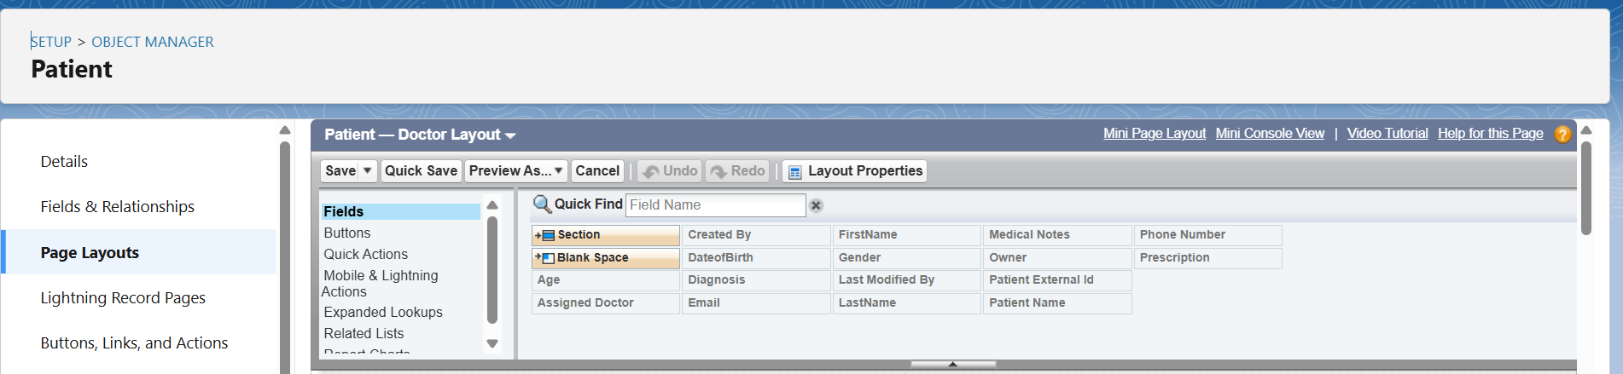

### 5. Compact Layouts

* Configured compact layout for **Patient**:
  + Fields: LastName, Phone, Assigned_Doctor__c, Next_FollowUp_Date__c.
* Compact layout set as **Primary** for all profiles.

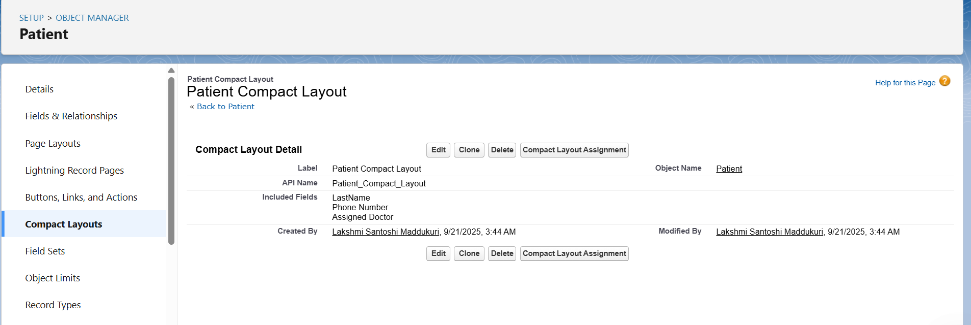

### 6. Schema Builder

* Used Schema Builder to visualize relationships:
  + Patient__c (Master) → Appointment__c, Treatment_Plan__c, FollowUp_Schedule__c (Detail).
  + Appointment__c → Lookup → Clinic_Location__c.

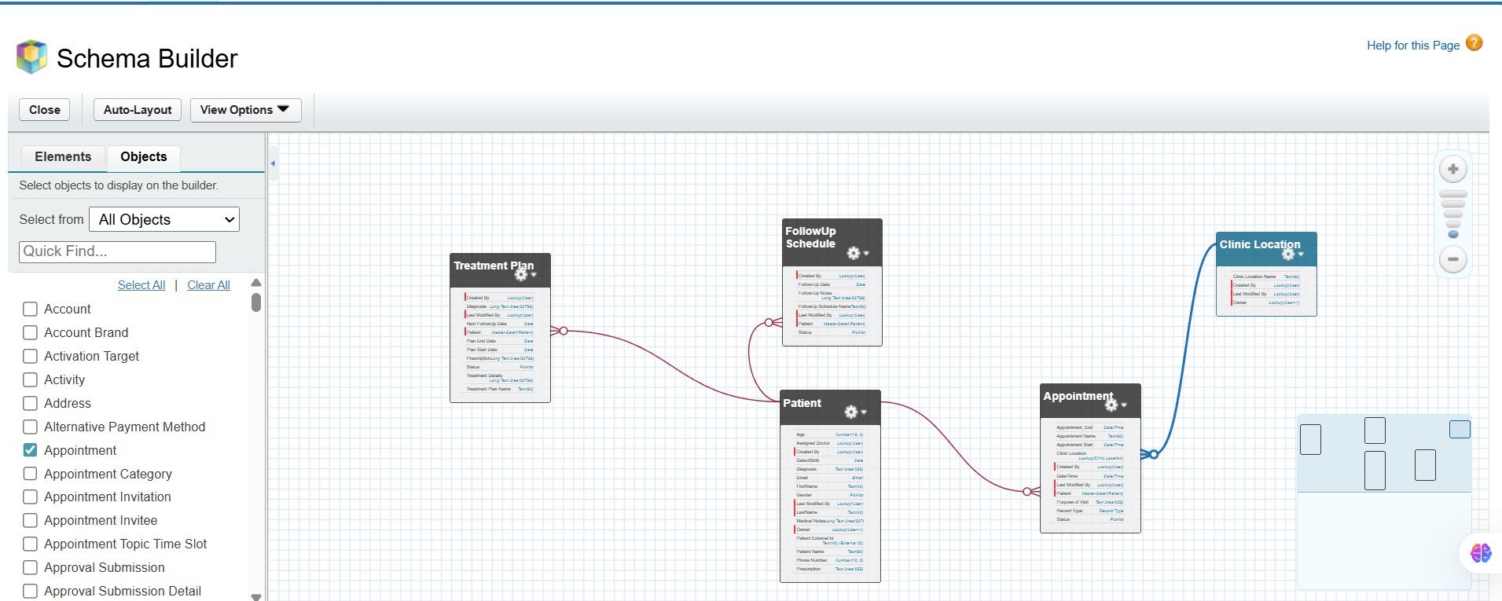

### 7. Relationships (Lookup vs Master-Detail vs Hierarchical)

* **Master-Detail:** Patient__c → Appointment__c, Treatment_Plan__c, FollowUp_Schedule__c.
* **Lookup:** Appointment__c → Clinic_Location__c.
* **Hierarchical:** Not used (only applies to User object).

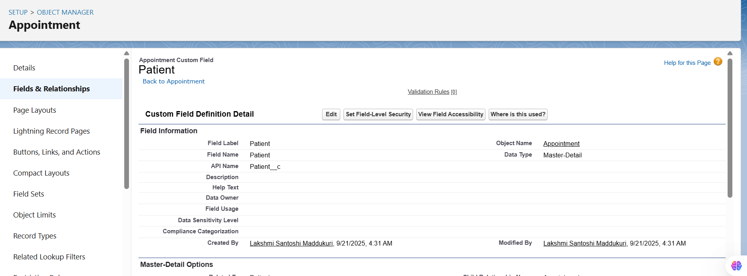

## 8. Junction Objects

We created a **junction object** to handle many-to-many relationships.

**Use Case in Healthcare CRM:**

* A patient can be treated by multiple doctors (specialists).
* A doctor can treat multiple patients.  
  👉 To model this, we created a **Patient_Doctor_Assignment__c** junction object.

**Configuration:**

* Custom Object: Patient_Doctor_Assignment__c
* Fields:
  + **Patient__c** (Master-Detail → Patient)
  + **Doctor__c** (Master-Detail → User)

**Result:**

* Many-to-Many between Patient and Doctor via Patient_Doctor_Assignment.
* Used in reports/dashboards to see “which doctor is treating which patients.”

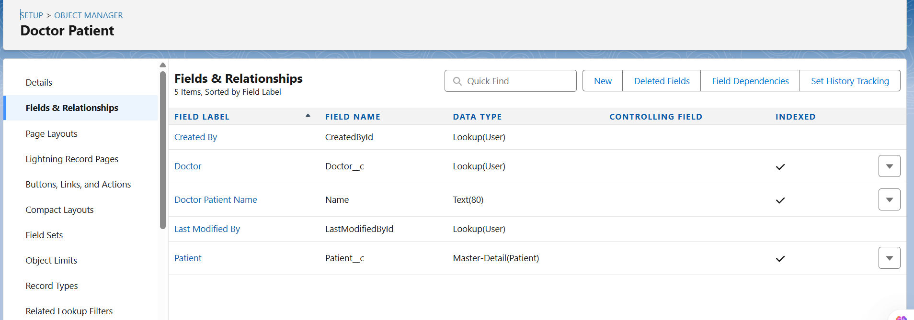

## 9. External Objects

We configured an **External Data Source** to prepare for integration with hospital billing/lab systems.

**Steps:**

1. Created Named Credential: HospitalBilling_NC (No Authentication, placeholder).
2. Created External Data Source: HospitalBilling_EDS (OData 4.0).
3. Attempted Validate & Sync → error due to Developer Org proxy.

**Result:**

* External Objects (Invoice__x, Customer__x) were planned but not synced in Dev Org.
* This step will be completed in **Phase 7 (Integrations)**.

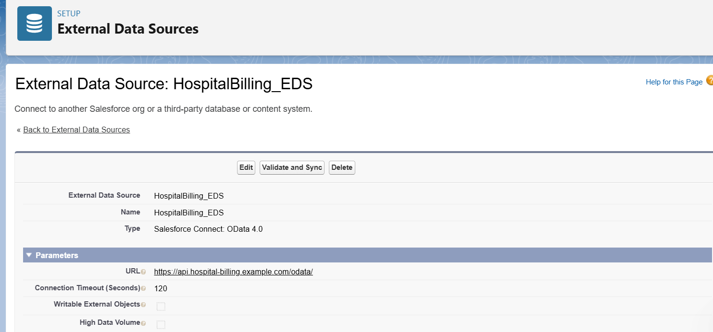

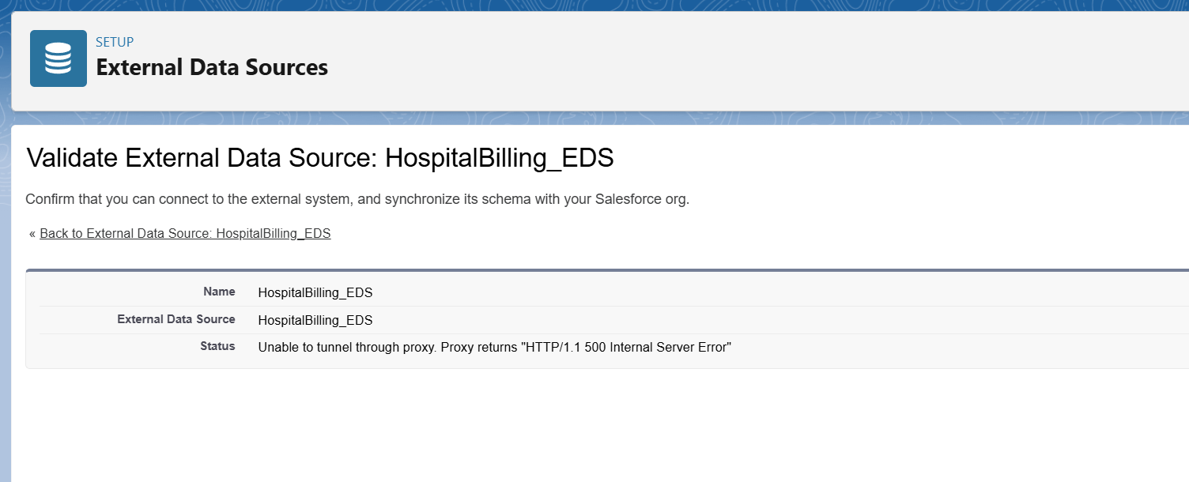

**Phase 4 — Process Automation (Admin)**

**Goal:** Automate validation, reminders, approvals and routine actions so patients don’t miss follow-ups and staff get notified automatically.

**1. Validation Rules**

**Purpose:** To enforce data quality by preventing invalid records.  
**Example:** Prevent users from creating appointments in the past.

**Steps:**

1. Setup → Object Manager → Appointment → Validation Rules → New.
2. Rule Name: Prevent_Appointment_In_Past.
3. Formula:
4. Appointment_Start__c < NOW()
5. Error Message: *Appointment cannot be scheduled in the past.*

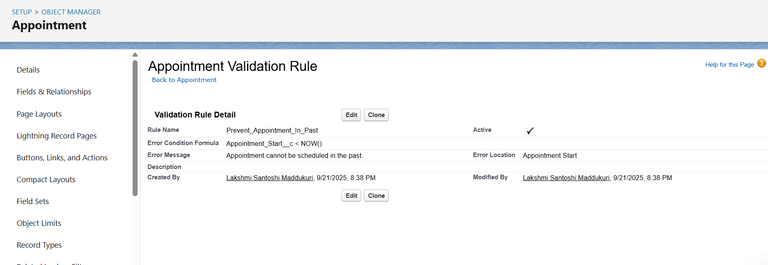

## ****2. Workflow Rules (Legacy)****

**Purpose:** Legacy automation (not recommended for new builds, but demonstrated).  
**Example:** When an appointment is marked "Missed", create a follow-up Task.

**Steps:**

1. Setup → Workflow Rules → New Rule → Object = Appointment.
2. Criteria: Appointment_Status__c = 'Missed'.
3. Immediate Action → New Task.
   * Subject: Follow up missed appointment
   * Assigned To: User/Queue
   * Priority: High
4. Save & Activate.

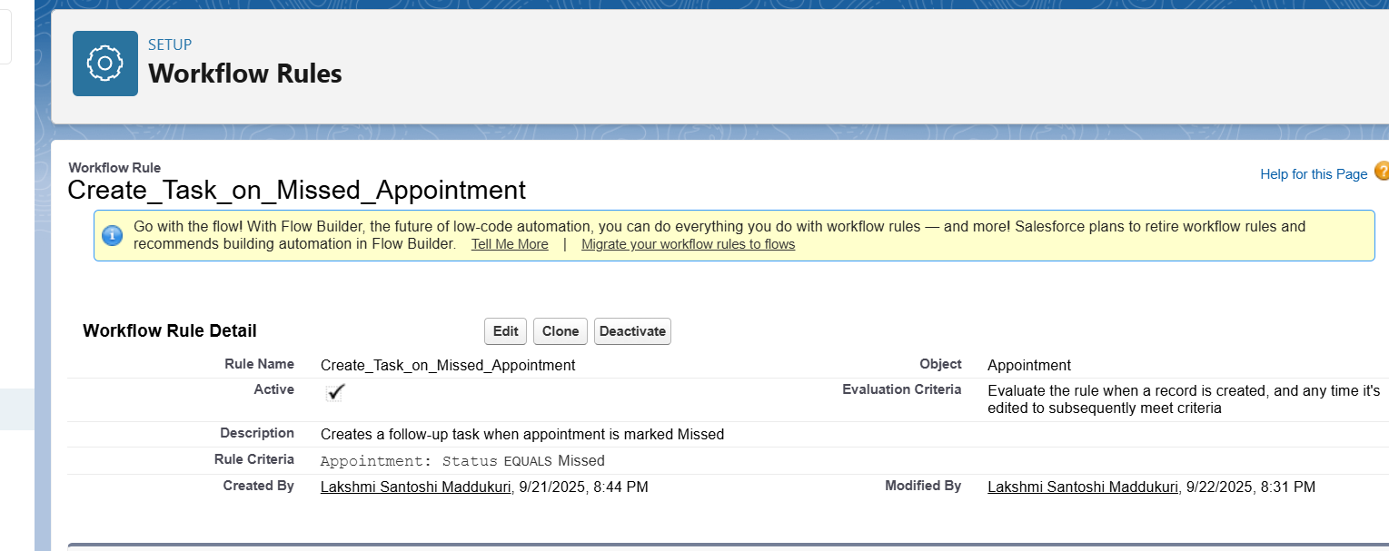

## ****3.Process Builder (Legacy)****

**Purpose:** Automate creation of follow-up schedule for patients with chronic disease.

**Steps:**

1. Setup → Process Builder → New.
2. Object: Patient, Start when record is created/edited.
3. Criteria: Chronic_Disease__c = TRUE.
4. Immediate Action → Create Record → FollowUp_Schedule__c.
   * Patient__c = [Patient].Id
   * Scheduled_Date__c = Today + 30.
5. Save & Activate.

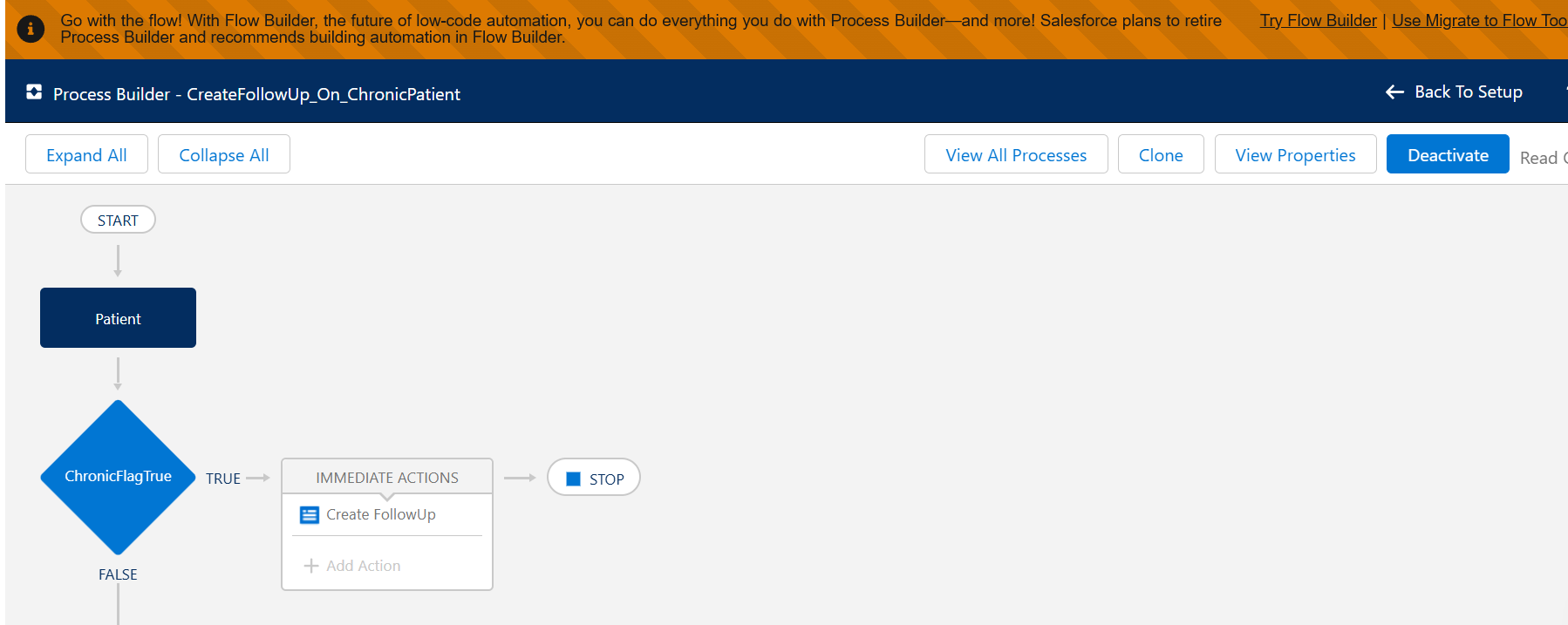

## ****4. Approval Process****

**Purpose:** Require approval before cancelling an appointment.

**Steps:**

1. Setup → Approval Processes → Object = Appointment.
2. Name: Appointment_Cancel_Approval.
3. Entry Criteria: Cancel_Request__c = TRUE.
4. Approver: Hospital Admin (or assigned role).
5. Final Approval Action:
   * Field Update → Appointment_Status__c = Cancelled.
   * Email Alert → Patient.
6. Final Rejection Action: Reset Cancel_Request__c = FALSE.
7. Add **Submit for Approval** to Appointment Page Layout.
8. Save & Activate.

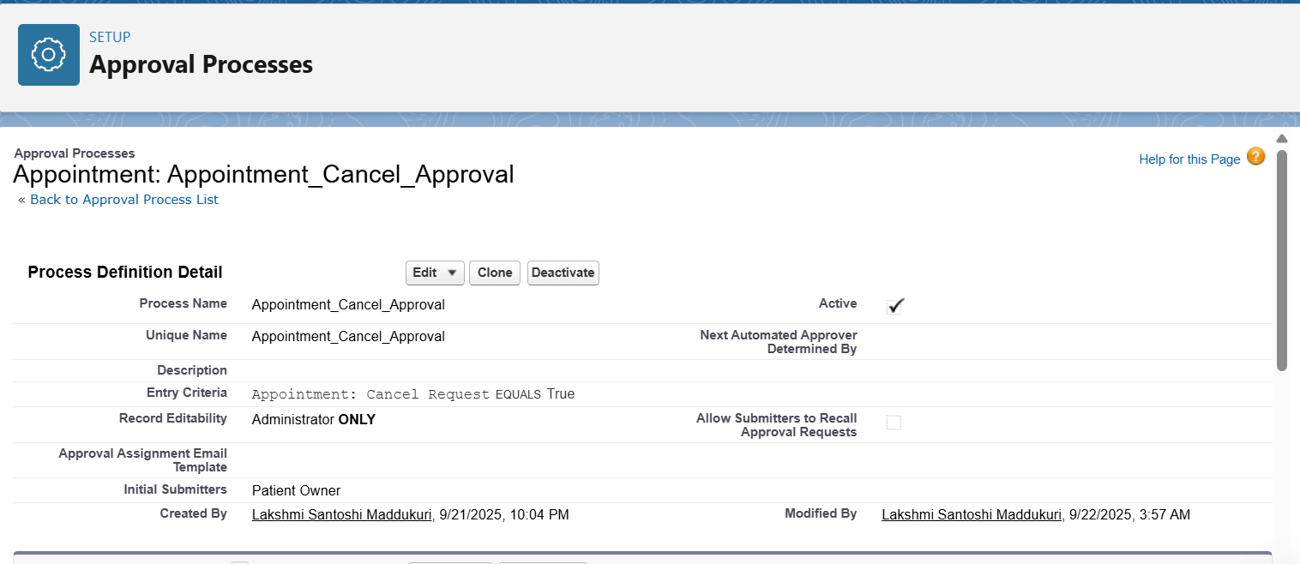

**5. Flow Builder**

Flows are the recommended automation tool. We built **four types** of flows.

**A) Record-Triggered Flow — Appointment Reminder (24 hours before)**

1. Flow → New → Record-Triggered Flow.
2. Object = Appointment.
3. Entry Conditions:
   * Appointment_Status__c = Scheduled
   * Appointment_Start__c != null
4. Add Scheduled Path → Offset = -1 Day before Appointment_Start__c.
5. Action: Send Email Alert (Appointment_Reminder_Template).
6. Save & Activate.

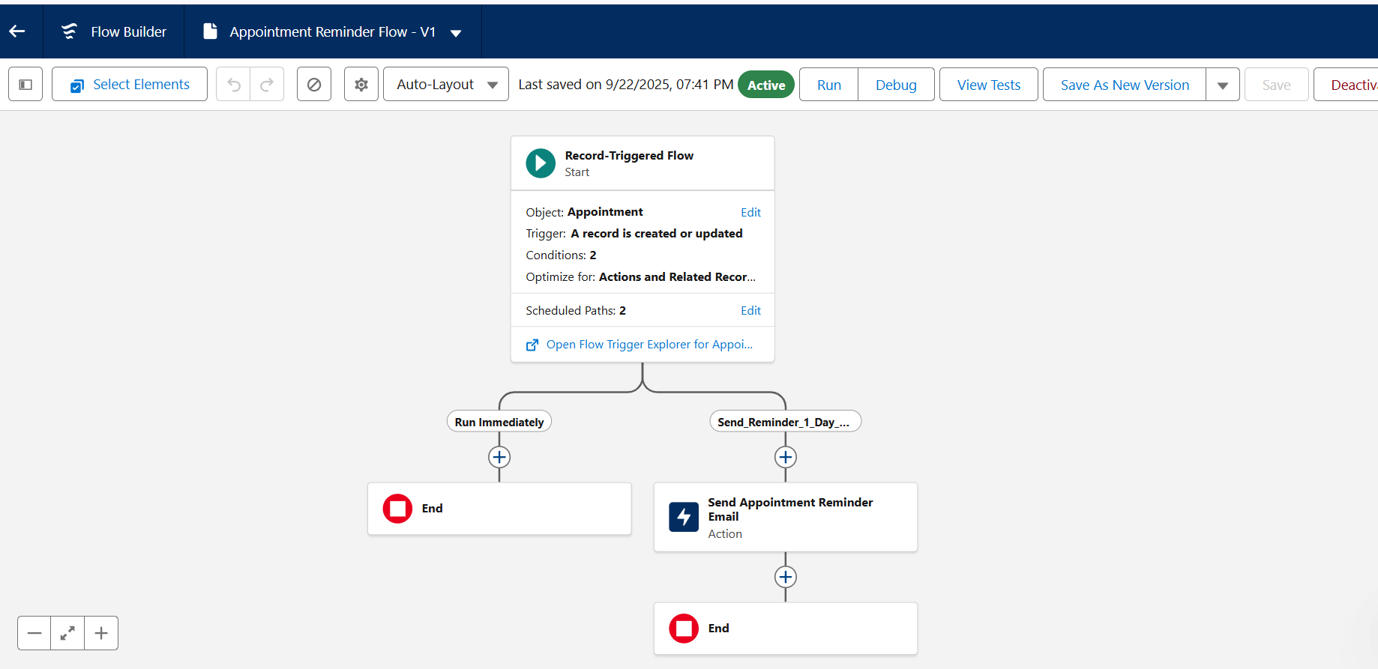

**B) Schedule-Triggered Flow — Daily Batch Reminders**

1. Flow → New → Schedule-Triggered Flow.
2. Schedule: Daily at 6:00 AM.
3. Get Records: Appointments where Appointment_Start__c = Tomorrow and Status = Scheduled.
4. Loop through records.
5. Inside loop: Send Email / Create Task / Custom Notification.
6. Save & Activate.

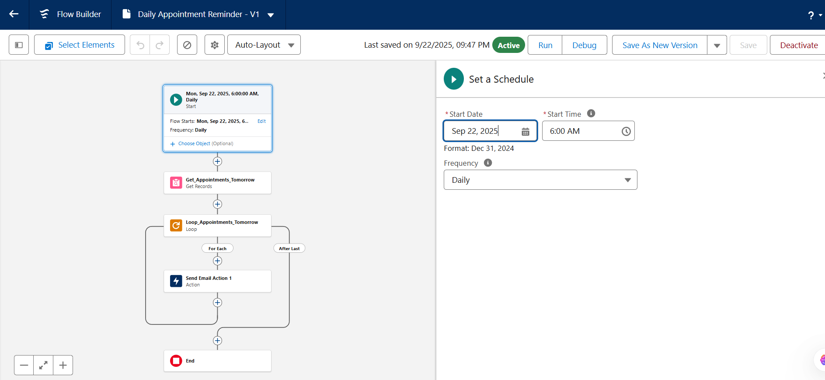

**C) Screen Flow — Receptionist Quick Schedule**

1. Flow → New → Screen Flow.
2. Add Screen:
   * Record Choice Set → Patient.
   * Date/Time Picker → Appointment Date.
   * Text → Reason.
3. Create Records: Appointment.
   * Patient__c = {!PatientChoice}
   * Appointment_Start__c = {!apptDateTime}
   * Status = Scheduled.
4. Save & Activate.
5. Add as Quick Action to Patient record page.

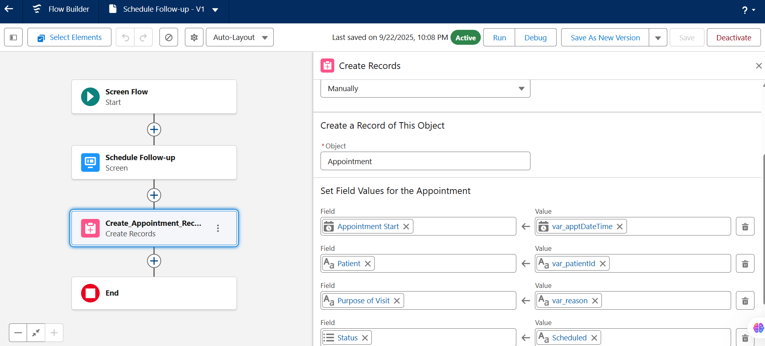

**D) Auto-Launched Flow — Reusable Logic**

1. Flow → New → Auto-Launched Flow.
2. Variable: patientId (Text, Available for Input).
3. Formula: Follow_Up_Date = TODAY() + 30.
4. Create Records: FollowUp_Schedule__c.
   * Patient__c = {!patientId}
   * Follow_Up_Date__c = {!Follow_Up_Date}.
5. Save & Activate.

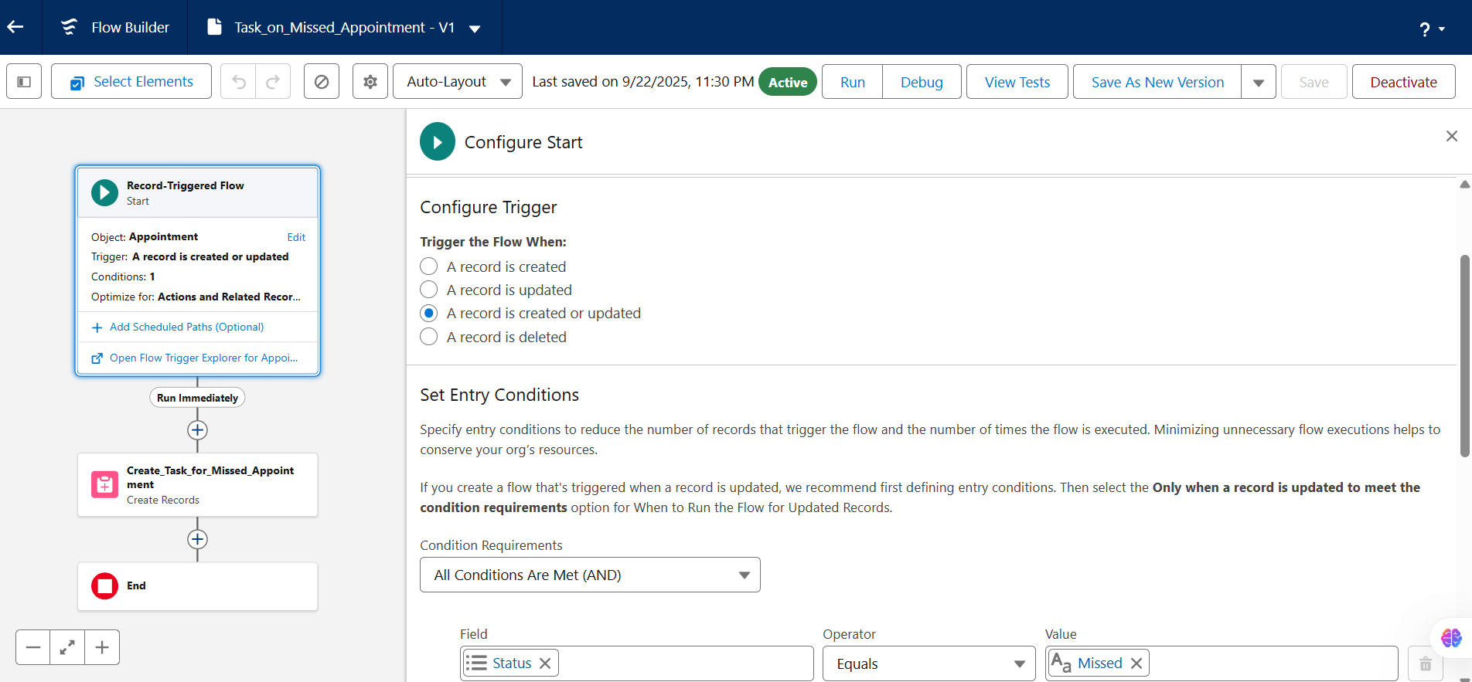

**6. Email Alerts**

**Purpose:** To notify patients of upcoming appointments.

**Steps:**

1. Setup → Email Templates → New → Lightning Email Template.
   * Related Entity = Appointment.
   * Subject: Reminder: Appointment on {!Appointment.Appointment_Start__c}.
   * Body: Hello {!Appointment.Patient__r.Name}, your appointment is scheduled for {!Appointment.Appointment_Start__c}.
2. Setup → Email Alerts → New.
   * Object: Appointment.
   * Email Template: Appointment_Reminder_Template.
   * Recipient: Patient.Email.
3. Save.

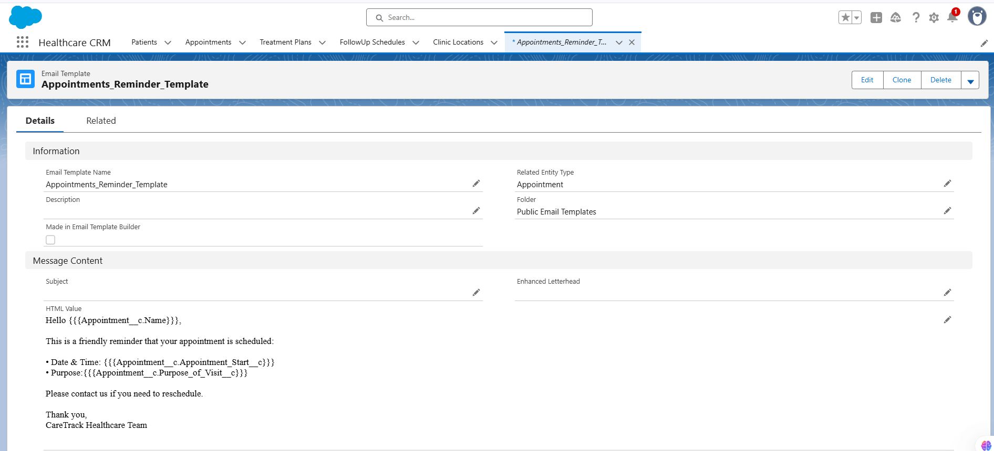

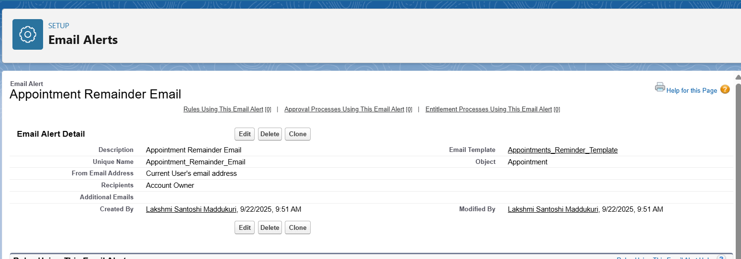

**7. Field Updates**

**Purpose:** Mark appointments as completed when follow-up is done.

**Steps:**

1. Flow → New → Record-Triggered Flow.
2. Object: Appointment.
3. Entry Condition: FollowUp_Completed__c = TRUE.
4. Action: Update Records (or Assignment in before-save).
   * Set Appointment_Status__c = Completed.
5. Save & Activate.

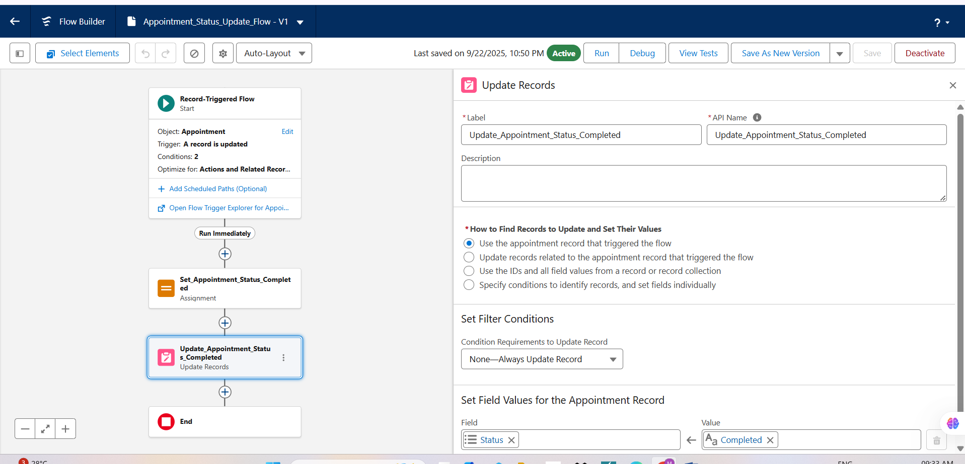

**8. Tasks**

**Purpose:** Create Tasks when appointments are missed.

**Steps:**

1. Flow → New → Record-Triggered Flow.
2. Object: Appointment.
3. Condition: Appointment_Status__c = Missed.
4. Action: Create Task.
   * Subject: Follow up missed appointment for {!$Record.Patient__r.Name}.
   * Priority: High.
   * Status: Not Started.
   * Due Date: Today + 1.
   * WhatId = Patient__c.
   * OwnerId = Receptionist/Owner.
5. Save & Activate.

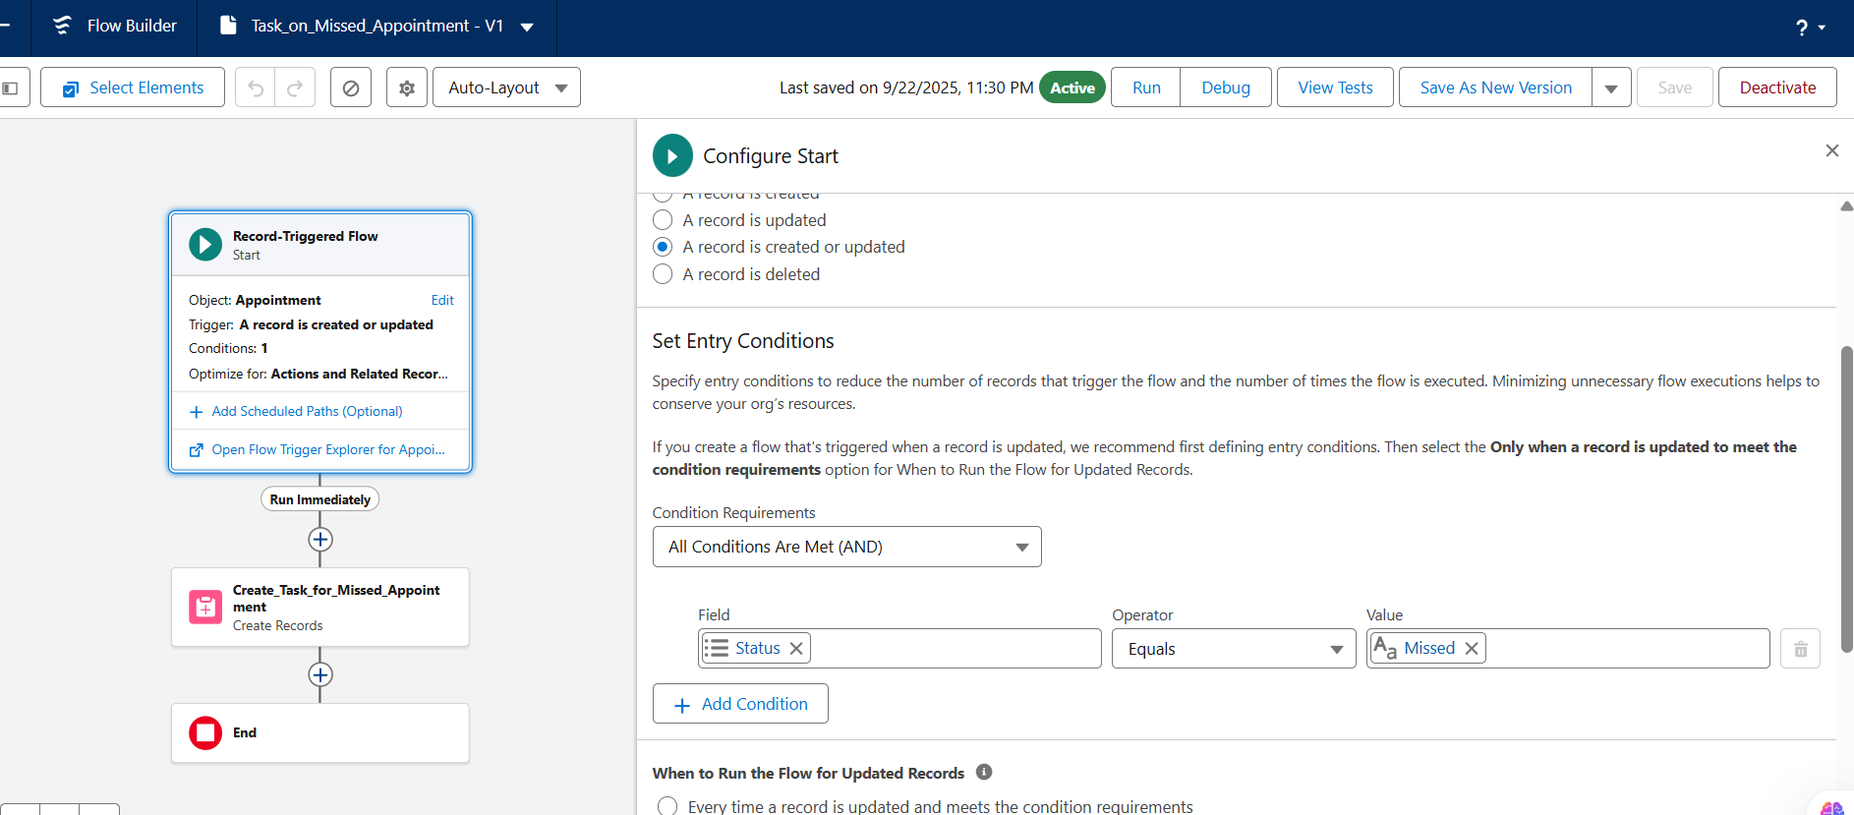

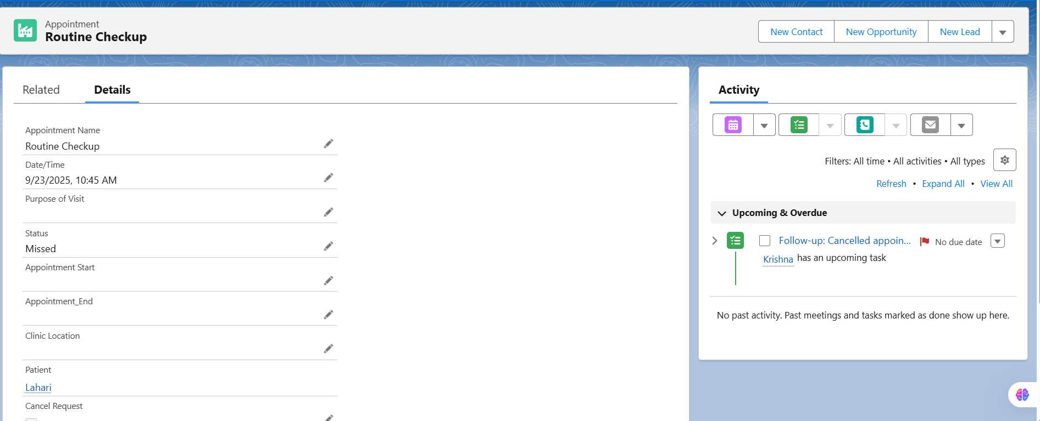

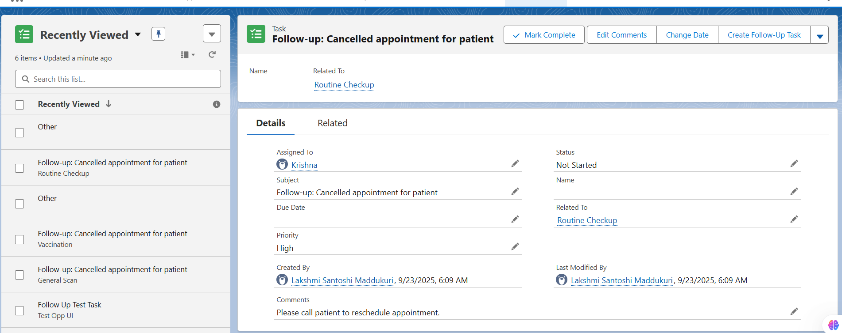

**9. Custom Notifications**

**Purpose:** Send in-app/mobile reminders.

**Steps:**

1. Setup → Notification Builder → Custom Notifications → New.
   * Name: Appointment_Reminder.
   * Channels: Desktop & Mobile.
2. Flow Action → Send Custom Notification.
   * Type: Appointment_Reminder.
   * Title: Appointment Reminder.
   * Body: Appointment tomorrow at {!$Record.Appointment_Start__c}.
   * Recipient: User Id (admin or assigned).
   * Target Record Id = Appointment Id.
3. Save & Activate.

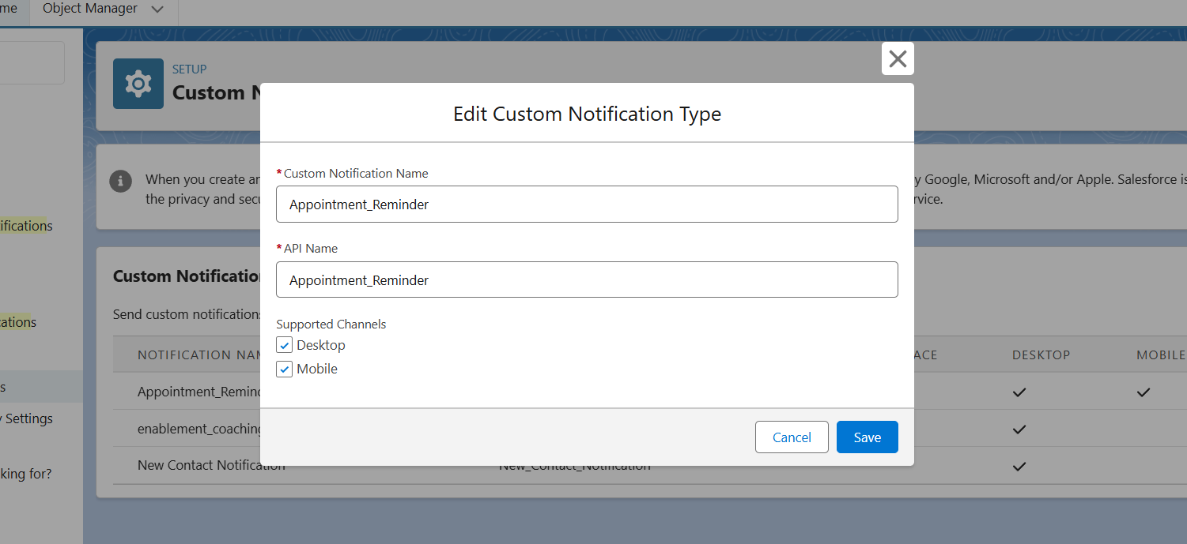

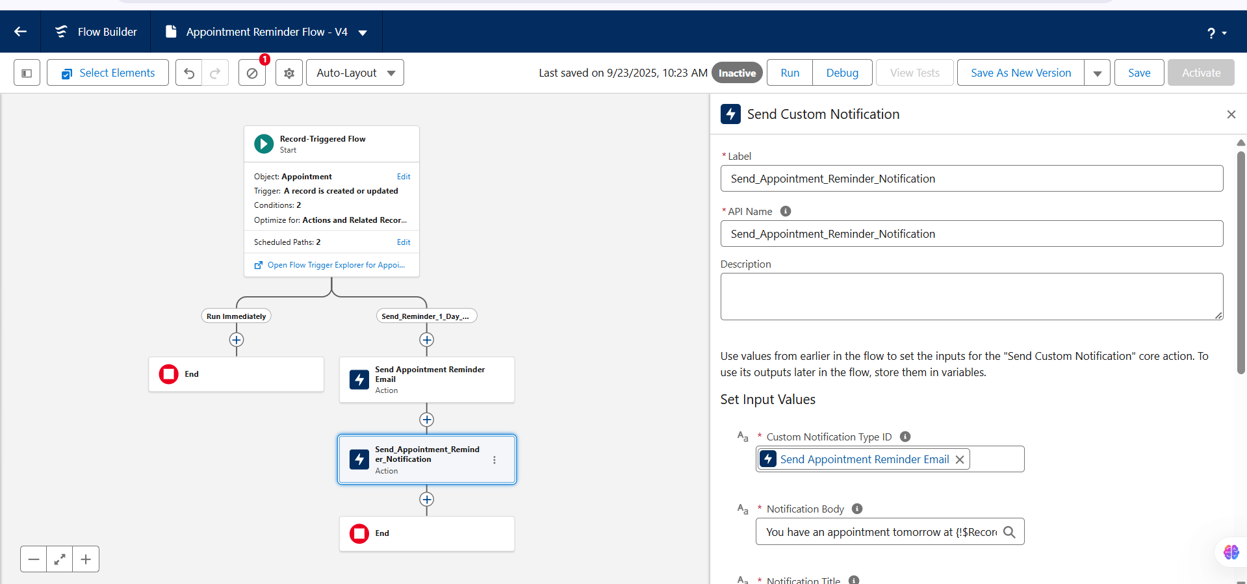

# **Phase 5 – Apex Programming (Developer)**

### Goal:-

### To extend the Healthcare Follow-up & Preventive Care CRM with **programmatic automation** using Apex. This phase demonstrates how to handle complex business logic (missed appointments, follow-ups, reminders) where **declarative tools (Flows/Process Builder)** may not be sufficient.

## 1. ****Apex Class****

### Use Case

We created an Apex Class PatientFollowUpService to encapsulate reusable logic for creating Follow-Up Schedule records. Instead of writing the same logic in multiple places, this class centralizes the functionality. Doctors or staff may use this service (indirectly via triggers or scheduled jobs) to automatically generate follow-up reminders for patients.

### PatientFollowUpService.apxc:-

### public with sharing class PatientFollowUpService {

### public static void createFollowUp(Id patientId, Date followUpDate) {

### FollowUp_Schedule__c f = new FollowUp_Schedule__c(

### Patient__c = patientId,

### Follow_Up_Date__c = followUpDate,

### Follow_Up_Notes__c = 'Auto-created via Apex Service'

### );

### insert f;

### }

### }

## 2. ****Apex Trigger****

### Use Case

We implemented a trigger AppointmentTrigger on the Appointment__c object. The business need was:

* When an **Appointment** is marked as **Missed**, the system should automatically create a **Follow-Up Schedule** record.
* The follow-up is set 7 days after the missed appointment, and a note is added.

This ensures that no missed appointment is forgotten, improving patient engagement and continuity of care.

**AppointmentTrigger.apxt:-**

trigger AppointmentTrigger on Appointment__c (after update) {

List<FollowUp_Schedule__c> newFollowUps = new List<FollowUp_Schedule__c>();

for (Appointment__c appt : Trigger.new) {

Appointment__c oldAppt = Trigger.oldMap.get(appt.Id);

if (appt.Status__c == 'Missed' && oldAppt.Status__c != 'Missed') {

newFollowUps.add(new FollowUp_Schedule__c(

Patient__c = appt.Patient__c,

Follow_Up_Date__c = Date.today().addDays(7), // ✅ corrected

Follow_Up_Notes__c = 'Auto-created for missed appointment'

));

}

}

if (!newFollowUps.isEmpty()) {

try {

insert newFollowUps;

} catch (DmlException e) {

System.debug('Error while inserting follow-ups: ' + e.getMessage());

}

}

}

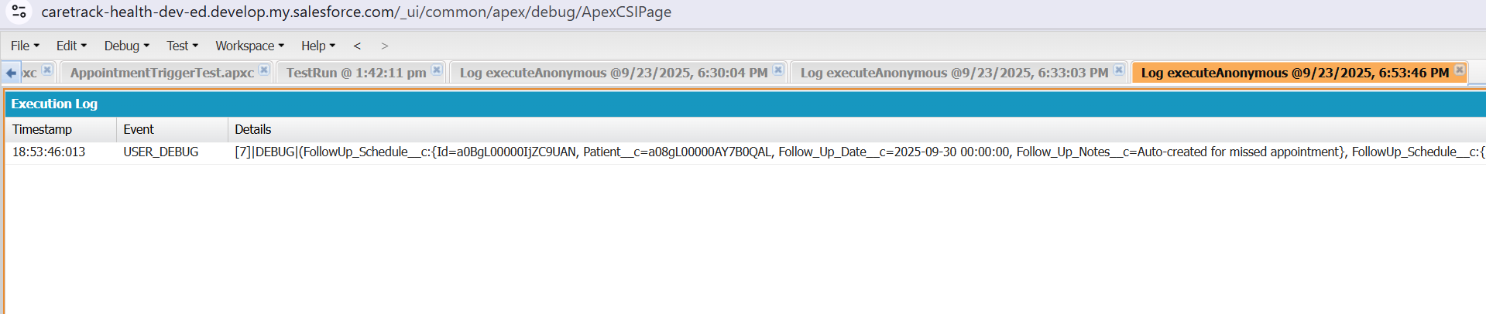

### 

## 3. ****SOQL Queries****

### Use Case

We used SOQL (Salesforce Object Query Language) to fetch patients with upcoming follow-ups in the next 7 days. This allows hospital staff or administrators to generate reports and track which patients need to be contacted.

**QUERY:-**

SELECT Id, Name,Phone_Number__c

FROM Patient__c

WHERE Id IN (

SELECT Patient__c

FROM FollowUp_Schedule__c

WHERE Follow_Up_Date__c = NEXT_N_DAYS:7

)

## 4. ****Scheduled Apex****

### Use Case

We developed DailyFollowUpScheduler, a scheduled Apex class that runs every morning at 7 AM. Its purpose is to find all patients who have follow-ups due **today** and send reminders (or log notifications for now).

This ensures hospital staff are aware of daily follow-ups without manually running reports.

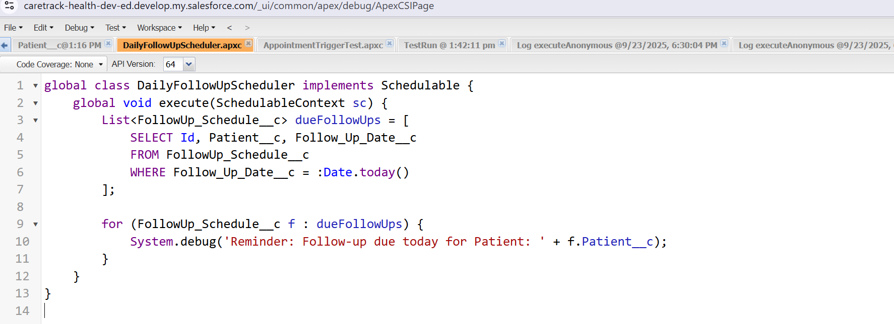

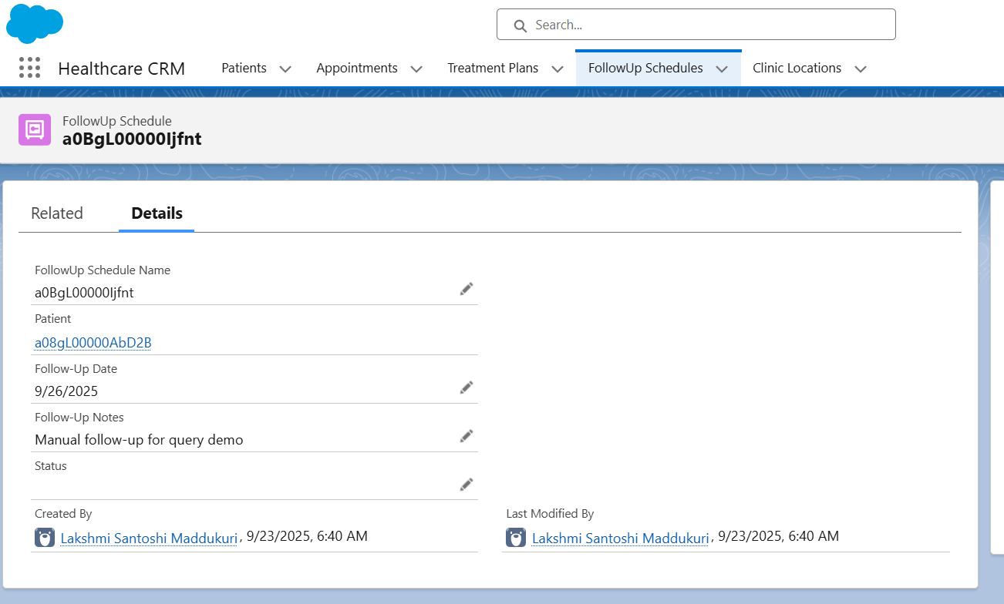

## 5. ****Exception Handling****

### Use Case

In our trigger, we wrapped the insert operation in a try-catch block. This ensures that even if one record fails (e.g., due to validation issues), the system logs the error instead of breaking the entire transaction.This adds robustness to the automation and helps admins debug issues without impacting users.

try {

// Missing required Patient__c field → will cause DML error

FollowUp_Schedule__c f = new FollowUp_Schedule__c(

Follow_Up_Date__c = Date.today().addDays(5),

Follow_Up_Notes__c = 'Testing exception handling'

);

insert f;

} catch (DmlException e) {

System.debug('❌ Caught error: ' + e.getMessage());

## 

## 6. ****Test Class****

### Use Case

Salesforce requires at least 75% test coverage for deployment. We created AppointmentTriggerTest to:

* Insert a test Patient and Appointment.
* Update the Appointment to “Missed”.
* Verify that a Follow-Up record was auto-created.

Our test achieved **91% coverage** for AppointmentTrigger. This ensures that the automation works as expected and can be safely deployed.

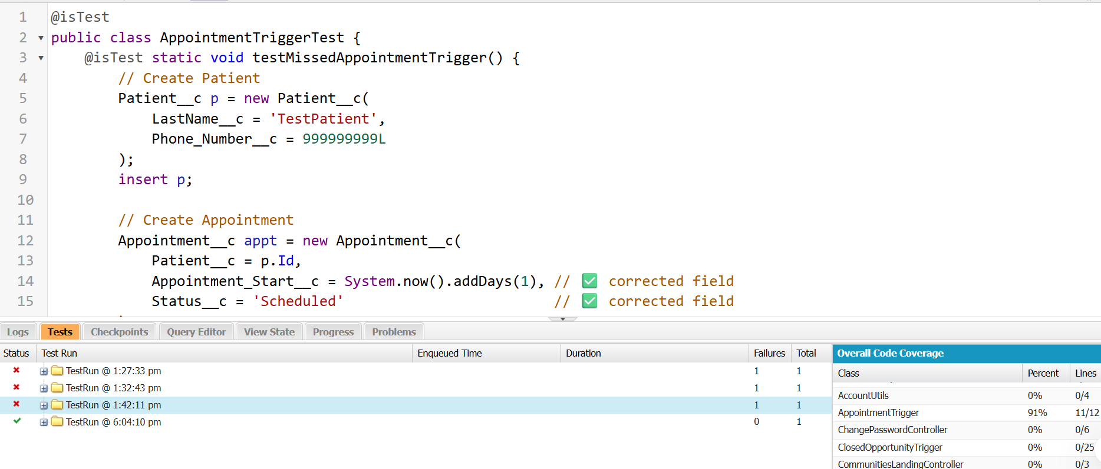

# **Summary of Phase 5**

* **Apex Class**: Encapsulated reusable follow-up creation logic.
* **Apex Trigger**: Automated creation of follow-ups for missed appointments.
* **SOQL**: Enabled querying of patients with upcoming follow-ups.
* **Scheduled Apex**: Automated daily reminders for due follow-ups.
* **Exception Handling**: Ensured robustness against data errors.
* **Test Class**: Achieved 91% coverage, validating functionality.

# **Phase 6: User Interface Development**

## 1. Record Pages

### Use Case

We customized the **Patient record page** to provide doctors and admins with quick access to patient details, appointments, and follow-ups. Instead of only showing default fields, we embedded our **Upcoming Followups LWC** directly in the record page. This allows users to see and create follow-ups without leaving the patient’s profile.

### Implementation

* Used **Lightning App Builder** to edit the Patient record page.
* Added standard components like **Record Highlights** and **Related Lists**.
* Dragged and placed the custom LWC upcomingFollowups into the side panel.
* Activated the page as the **App Default** for CareTrack Health.

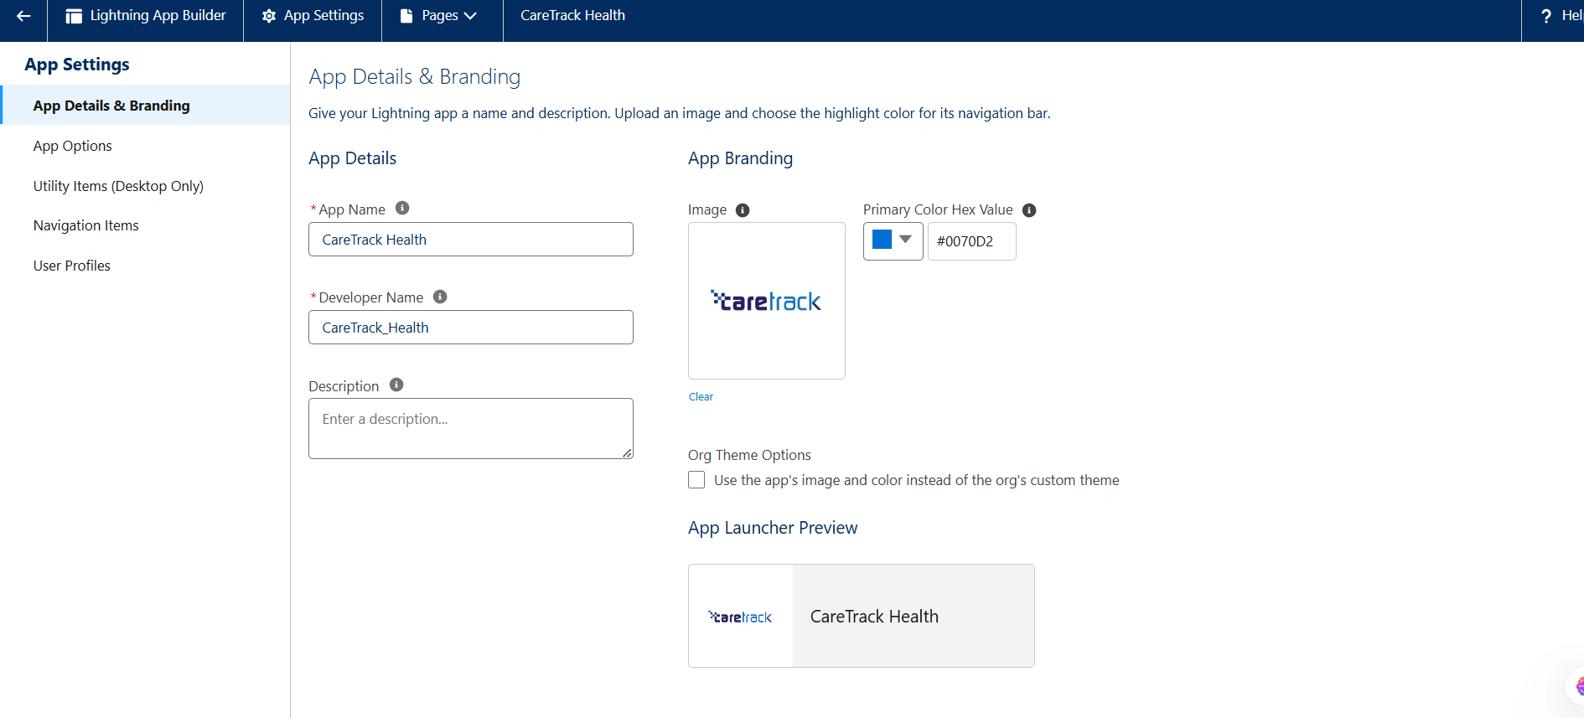

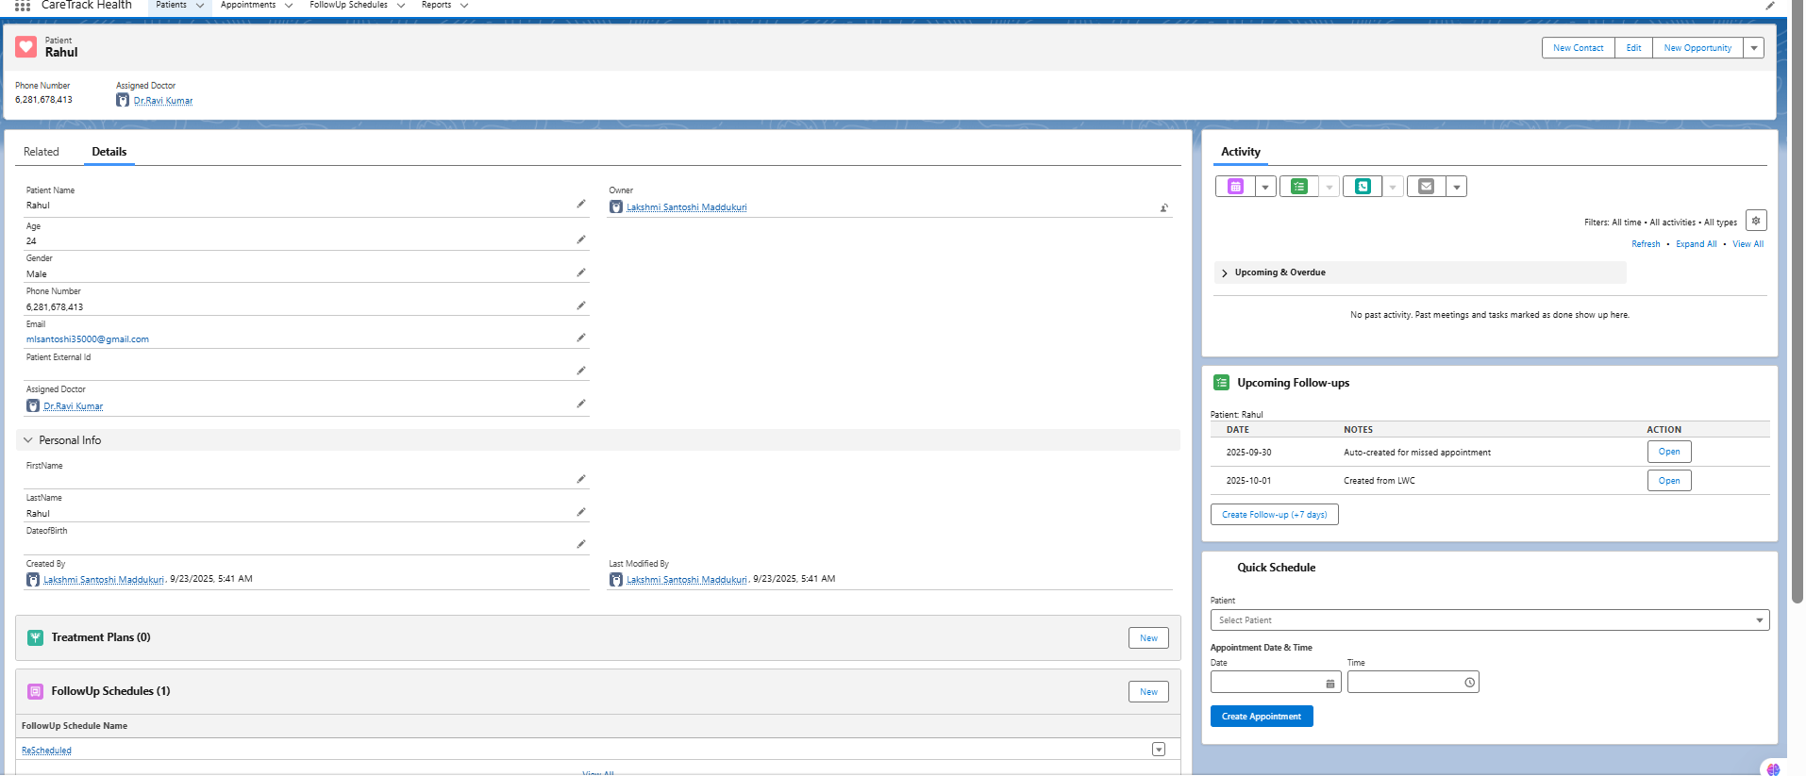

## 2. Home Page Layouts

### Use Case

We wanted a **dashboard-like homepage** for CareTrack Health so users can quickly see patients, appointments, and follow-up information.

### Implementation

* Created a custom **Home Page** in Lightning App Builder.
* Added:
  + **Rich Text** → Welcome message.
  + **List Views** → Recent Patients/Appointments.
  + **Custom LWC** (upcomingFollowups or summary component).
* Activated as default for **CareTrack Health app**.

### 

### 

## 3. Tabs

### Use Case

To improve navigation, we created **custom tabs** for Patient, Appointment, and Follow-Up objects. This helps users access each record type directly from the app navigation bar.

### Implementation

* In **Setup → Tabs**, created custom tabs for Patient__c, Appointment__c, and FollowUp_Schedule__c.
* Added tabs to the **CareTrack Health app** in App Manager.

## 

## 4. Utility Bar (Quick Schedule)

### Use Case

We wanted a way to **create new appointments from anywhere** in the app without navigating to the Patient record. For this, we used the **Utility Bar** with a custom LWC quickSchedule.

### Implementation

* Built quickSchedule LWC with:
  + Patient dropdown (fetched via Apex).
  + Date & time input.
  + Button to create Appointment via **imperative Apex**.
* Configured the CareTrack Health app → Utility Items → added quickSchedule.

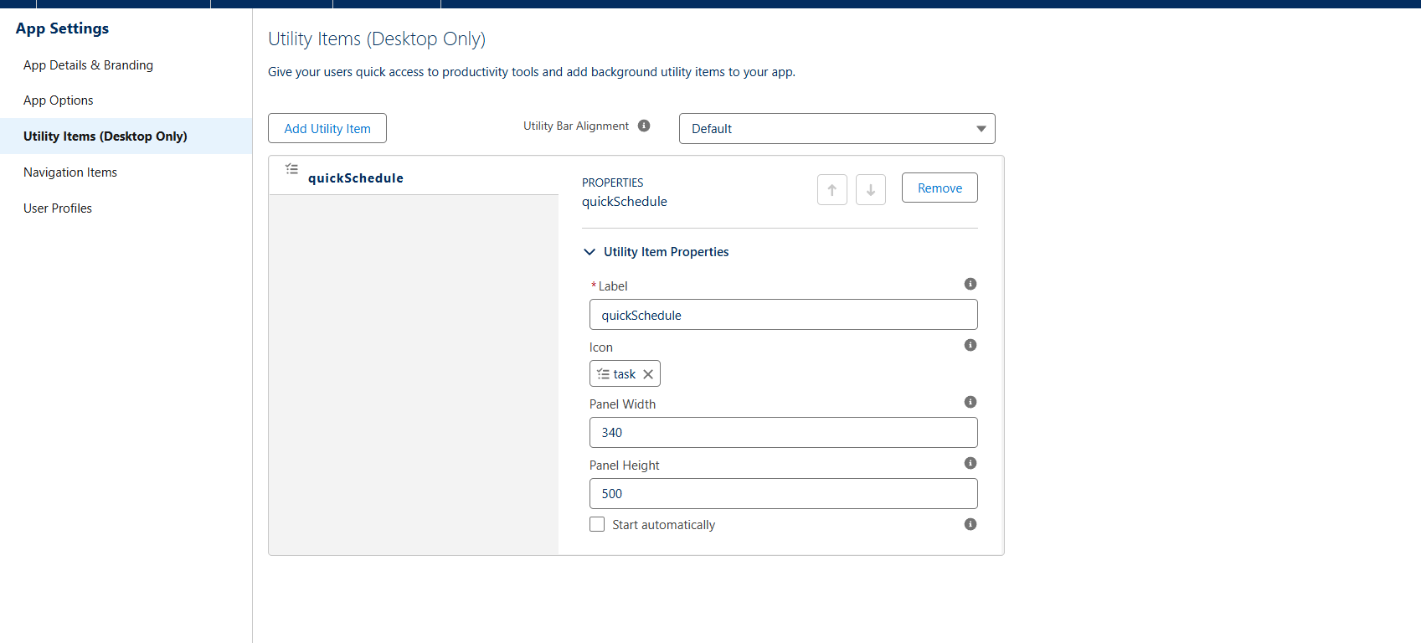

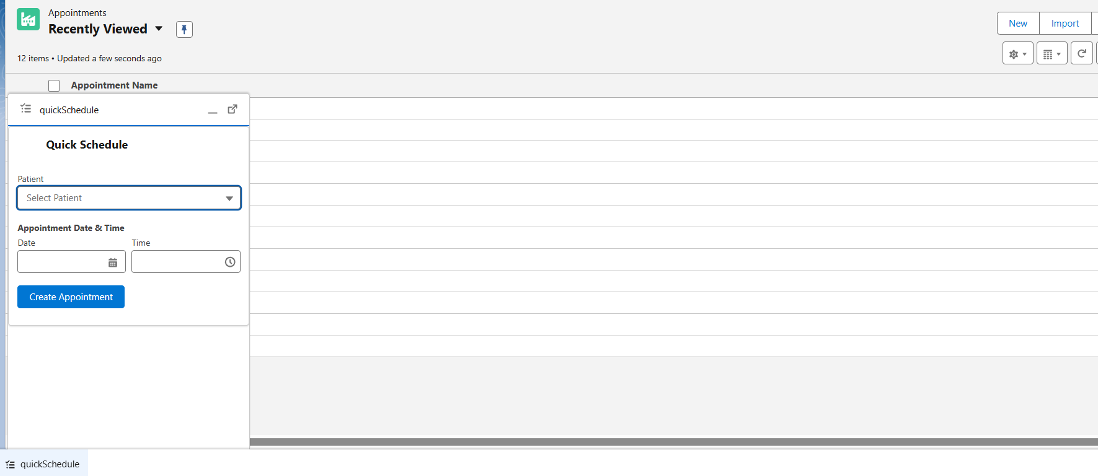

## 5. Lightning Web Components (LWC)

### Use Case

We developed LWCs to provide interactive UI functionality not possible with standard components.

#### **Example A — upcomingFollowups**

* Shows upcoming follow-ups for a patient.
* Uses **wire adapter (getRecord)** to fetch Patient Name.
* Uses **Apex (getUpcomingFollowUps)** to fetch records.
* Uses **imperative Apex (createFollowUp)** to create new records.
* Uses **refreshApex + custom events** to update the list automatically.
* Uses **NavigationMixin** to open records.

**upcoming Followups codes:-**

**upcoming Followups.html:-**

<template>

  <lightning-card title="Upcoming Follow-ups" icon-name="standard:task">

    <div class="slds-p-around_small">

      <template if:true={patientName}>

        <p class="slds-text-title_small">Patient: {patientName}</p>

      </template>

      <template if:true={followUps.length}>

        <table class="slds-table slds-table_cell-buffer slds-table_bordered">

          <thead>

            <tr class="slds-text-title_caps">

              <th scope="col">Date</th>

              <th scope="col">Notes</th>

              <th scope="col">Action</th>

            </tr>

          </thead>

          <tbody>

            <template for:each={followUps} for:item="fu">

              <tr key={fu.Id}>

                <td>{fu.Follow_Up_Date__c}</td>

                <td>{fu.Follow_Up_Notes__c}</td>

                <td>

                  <lightning-button variant="neutral" label="Open" data-id={fu.Id} onclick={navigateToFollowUp}></lightning-button>

                </td>

              </tr>

            </template>

          </tbody>

        </table>

      </template>

      <template if:false={followUps.length}>

        <div class="slds-p-top_small">No upcoming follow-ups.</div>

      </template>

      <div class="slds-m-top_small">

        <lightning-button label="Create Follow-up (+7 days)" onclick={handleCreateFollowUp}></lightning-button>

      </div>

    </div>

  </lightning-card>

</template>

**upcomingFollowups.js:-**

import { LightningElement, api, track, wire } from 'lwc';

import getUpcomingFollowUps from '@salesforce/apex/UpcomingFollowupsController.getUpcomingFollowUps';

import createFollowUp from '@salesforce/apex/UpcomingFollowupsController.createFollowUp';

import { getRecord } from 'lightning/uiRecordApi';

import { NavigationMixin } from 'lightning/navigation';

// replace these if your object/field names differ:

const PATIENT_NAME_FIELD = 'Patient__c.Name';

export default class UpcomingFollowups extends NavigationMixin(LightningElement) {

  @api recordId; // when placed on Patient record page this is the patient Id

  @track followUps = [];

  patientName;

  connectedCallback() {

    // initial load via imperative call

    this.loadFollowUps();

  }

  // wire adapter to get patient name (example of wire adapter use)

  @wire(getRecord, { recordId: '$recordId', fields: [PATIENT_NAME_FIELD] })

  wiredPatient({ error, data }) {

    if (data) {

      // guard: some orgs return different field token; adapt if needed

      this.patientName = data.fields ? data.fields.Name.value : '';

    }

  }

  loadFollowUps() {

    if (!this.recordId) return;

    getUpcomingFollowUps({ patientId: this.recordId })

      .then(result => {

        this.followUps = result;

      })

      .catch(error => {

        // handle error (console + optional UI toast)

        // eslint-disable-next-line no-console

        console.error('Error loading follow-ups', error);

      });

  }

  handleCreateFollowUp() {

    if (!this.recordId) return;

    // create follow-up for +7 days (format yyyy-mm-dd)

    const d = new Date();

    d.setDate(d.getDate() + 7);

    const isoDate = d.toISOString().split('T')[0]; // "YYYY-MM-DD"

    createFollowUp({ patientId: this.recordId, followUpDateStr: isoDate })

      .then((newId) => {

        // refresh list

        this.loadFollowUps();

        // dispatch an event so parent or other components can react

        this.dispatchEvent(new CustomEvent('refresh'));

      })

      .catch(error => {

        // eslint-disable-next-line no-console

        console.error('Error creating follow-up', error);

      });

  }

  navigateToFollowUp(event) {

    const recId = event.currentTarget.dataset.id;

    if (!recId) return;

    this[NavigationMixin.Navigate]({

      type: 'standard__recordPage',

      attributes: {

        recordId: recId,

        objectApiName: 'FollowUp_Schedule__c',

        actionName: 'view'

      }

    });

  }

}

**upcomingFollowups.js-meta.xml:-**

<?xml version="1.0" encoding="UTF-8"?>

<LightningComponentBundle xmlns="http://soap.sforce.com/2006/04/metadata">

  <apiVersion>59.0</apiVersion>

  <isExposed>true</isExposed>

  <targets>

    <target>lightning__RecordPage</target>

    <target>lightning__AppPage</target>

    <target>lightning__HomePage</target>

  </targets>

  <targetConfigs>

    <targetConfig targets="lightning__RecordPage">

      <objects>

        <object>Patient__c</object>

      </objects>

    </targetConfig>

  </targetConfigs>

</LightningComponentBundle>

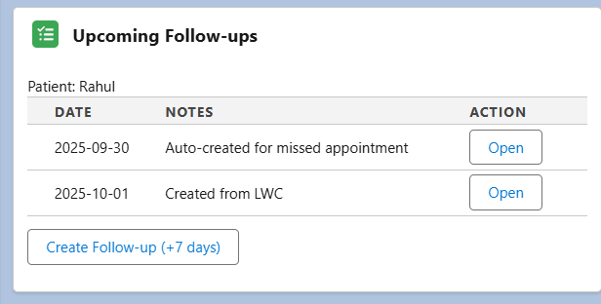

#### **Example B — quickSchedule**

* Provides quick appointment creation via Utility Bar.
* Uses **imperative Apex (createAppointment)**.
* Displays success/error toasts.
* Navigates to the newly created record.

#### **quickSchedule Codes:-**

***quickSchedule.html:-***

<template>

  <lightning-card title="Quick Schedule" icon-name="standard:calendar">

    <div class="slds-p-around_small">

      <lightning-combobox

        name="patient"

        label="Patient"

        options={patientOptions}

        value={selectedPatientId}

        placeholder="Select Patient"

        onchange={handlePatientChange}>

      </lightning-combobox>

      <div class="slds-m-top_small">

        <lightning-input

          type="datetime-local"

          label="Appointment Date & Time"

          value={appointmentDateTime}

          onchange={handleDateChange}>

        </lightning-input>

      </div>

      <div class="slds-m-top_small">

        <lightning-button

          variant="brand"

          label="Create Appointment"

          onclick={handleCreateAppointment}

          disabled={isCreating}>

        </lightning-button>

      </div>

    </div>

  </lightning-card>

</template>

## quickSchedule.js:-

import { LightningElement, track } from 'lwc';

import getPatients from '@salesforce/apex/QuickScheduleController.getPatients';

import createAppointment from '@salesforce/apex/QuickScheduleController.createAppointment';

import { ShowToastEvent } from 'lightning/platformShowToastEvent';

import { NavigationMixin } from 'lightning/navigation';

export default class QuickSchedule extends NavigationMixin(LightningElement) {

    @track patientOptions = [];

    selectedPatientId = '';

    appointmentDateTime = '';

    isCreating = false;

    // Load patients when component loads

    connectedCallback() {

        this.loadPatients();

    }

    // Fetch patients from Apex

    loadPatients() {

        getPatients()

            .then(result => {

                this.patientOptions = result.map(p => ({

                    label: p.Name,

                    value: p.Id

                }));

            })

            .catch(error => {

                this.showToast(

                    'Error loading patients',

                    error.body ? error.body.message : error.message,

                    'error'

                );

            });

    }

    handlePatientChange(event) {

        this.selectedPatientId = event.detail.value;

    }

    handleDateChange(event) {

        this.appointmentDateTime = event.target.value; // "yyyy-MM-ddTHH:mm"

    }

    handleCreateAppointment() {

        if (!this.selectedPatientId) {

            this.showToast('Validation', 'Please select a patient', 'warning');

            return;

        }

        if (!this.appointmentDateTime) {

            this.showToast('Validation', 'Please select appointment date & time', 'warning');

            return;

        }

        this.isCreating = true;

        createAppointment({

            patientId: this.selectedPatientId,

            appointmentDateTimeLocal: this.appointmentDateTime

        })

            .then(apptId => {

                this.showToast('Success', 'Appointment created successfully!', 'success');

                // Navigate to new Appointment record

                this[NavigationMixin.Navigate]({

                    type: 'standard__recordPage',

                    attributes: {

                        recordId: apptId,

                        objectApiName: 'Appointment__c',

                        actionName: 'view'

                    }

                });

            })

            .catch(error => {

                this.showToast(

                    'Error creating appointment',

                    error.body ? error.body.message : error.message,

                    'error'

                );

            })

            .finally(() => {

                this.isCreating = false;

            });

    }

    showToast(title, message, variant) {

        this.dispatchEvent(

            new ShowToastEvent({

                title: title,

                message: message,

                variant: variant

            })

        );

    }

}

## quickSchedule.js-meta.xml:-

<?xml version="1.0" encoding="UTF-8"?>

<LightningComponentBundle xmlns="http://soap.sforce.com/2006/04/metadata">

    <apiVersion>59.0</apiVersion>

    <isExposed>true</isExposed>

    <targets>

        <target>lightning__RecordPage</target>

        <target>lightning__UtilityBar</target>

        <target>lightning__AppPage</target>

        <target>lightning__HomePage</target>

    </targets>

</LightningComponentBundle>

## 

## 6. Apex with LWC

### Use Case

Our LWCs needed server-side logic for data operations. We implemented Apex controllers to handle this safely.

* UpcomingFollowupsController.cls: fetches upcoming follow-ups, creates new follow-ups.
* QuickScheduleController.cls: fetches patients and creates appointments.
* Both are marked **with sharing** for security and use @AuraEnabled.

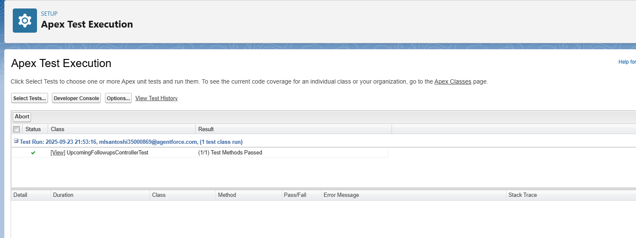

**Apex test results showing all tests passed for UpcomingFollowupsControllerTest.**

## 7. Events in LWC

### Use Case

To notify parent components and refresh data after creating a new follow-up, we used **Custom Events**.

### Implementation

* In upcomingFollowups.js:
* this.dispatchEvent(new CustomEvent('refresh'));
* This helps ensure UI updates dynamically.

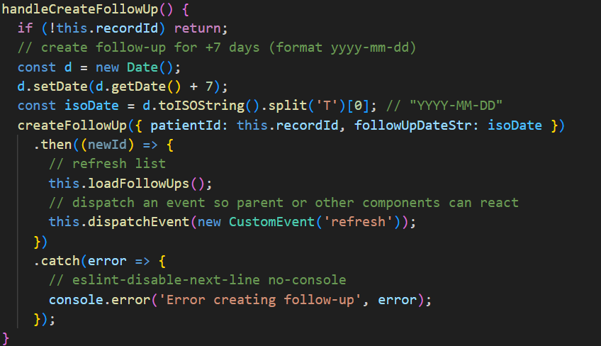

**UpcomingFollowups.js showing dispatchEvent used to notify parent components.**

## 8. Wire Adapters

### Use Case

We used **Lightning Data Service wire adapters** to fetch data without SOQL in the front-end.

### Implementation

* Used getRecord to retrieve **Patient Name** in upcomingFollowups.
* Reactive → whenever the recordId changes, the UI updates automatically.

## 

## UpcomingFollowups.js showing wire adapter (getRecord) fetching Patient Name

## 

## UpcomingFollowups LWC showing Patient Name fetched via wire adapter.

## 9. Imperative Apex Calls

### Use Case

For operations requiring user interaction (e.g., button click → create record), we used **imperative Apex calls**.

### Implementation

* createFollowUp() in upcomingFollowups.
* createAppointment() in quickSchedule.
* Both return record IDs and display success/error toasts.

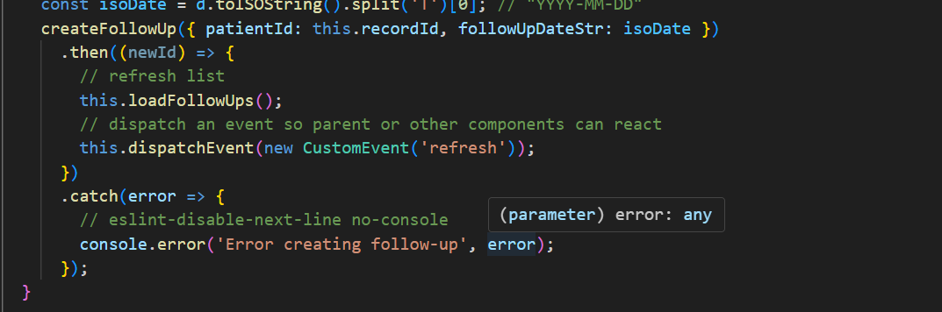

**createFollowUp() in upcomingFollowups.**

createAppointment({

            patientId: this.selectedPatientId,

            appointmentDateTimeLocal: this.appointmentDateTime

        })

            .then(apptId => {

                this.showToast('Success', 'Appointment created successfully!', 'success');

                // Navigate to new Appointment record

                this[NavigationMixin.Navigate]({

                    type: 'standard__recordPage',

                    attributes: {

                        recordId: apptId,

                        objectApiName: 'Appointment__c',

                        actionName: 'view'

                    }

                });

            })

**createAppointment() in quickSchedule.**

## 

## 10. Navigation Service

### Use Case

After creating or selecting a record, we used **NavigationMixin** to redirect users directly to the record detail page.

### Implementation

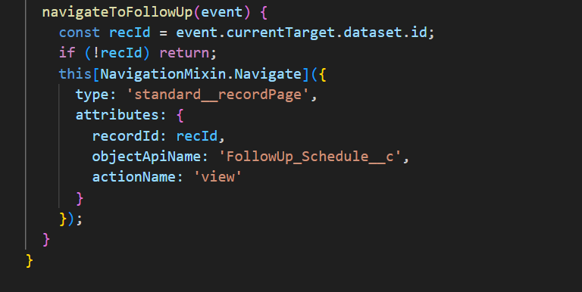

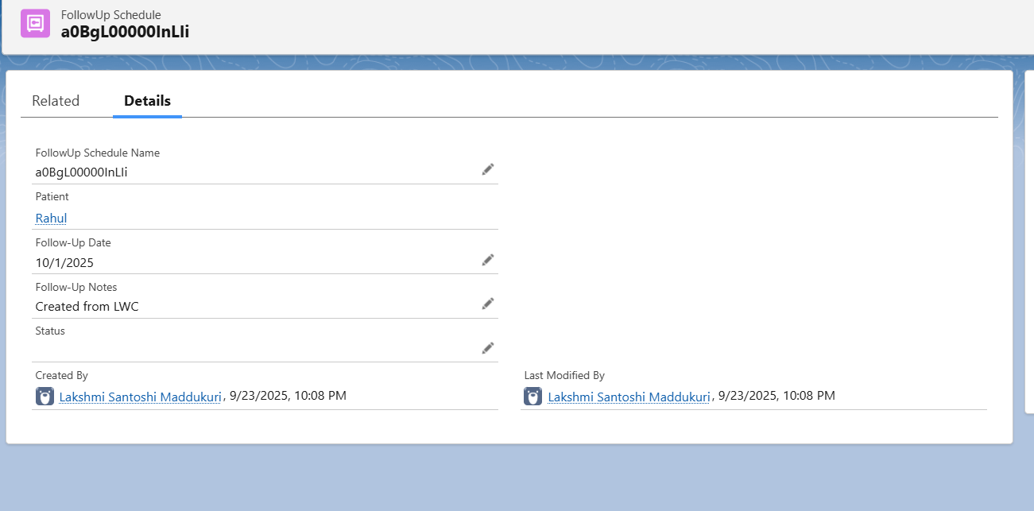

# **Phase 7: Integration & External Access**

**1. Named Credentials**

**Use Case**  
We used Named Credentials to securely store the endpoint URL and authentication settings for external APIs. This allowed Salesforce to call APIs without hardcoding credentials in Apex code.

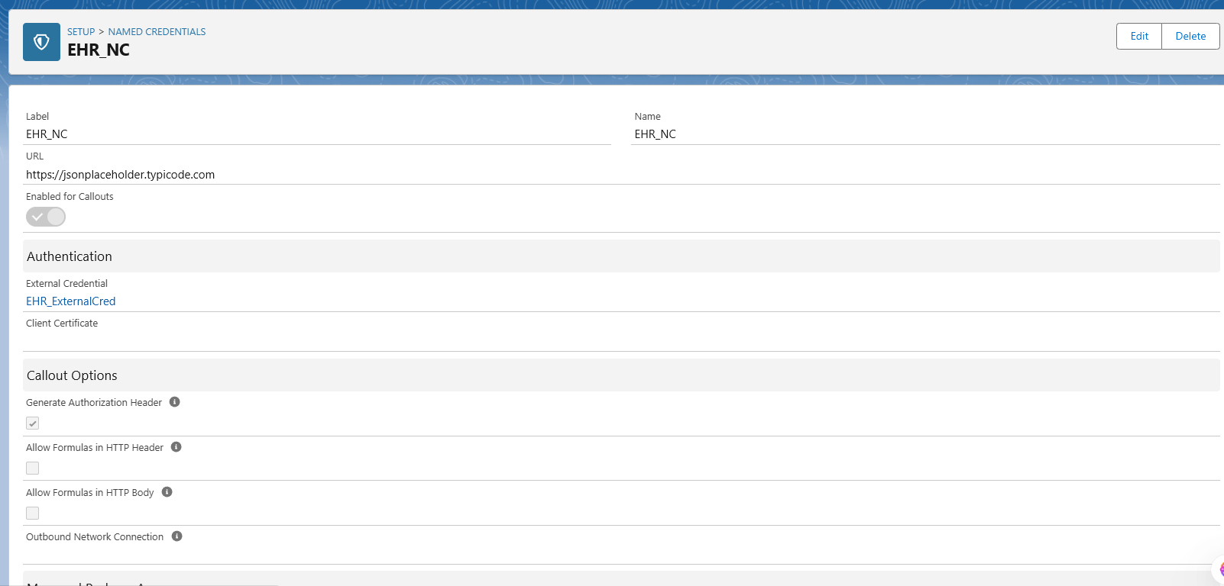

**Setup → Named Credentials → your EHR_NC detail page.**

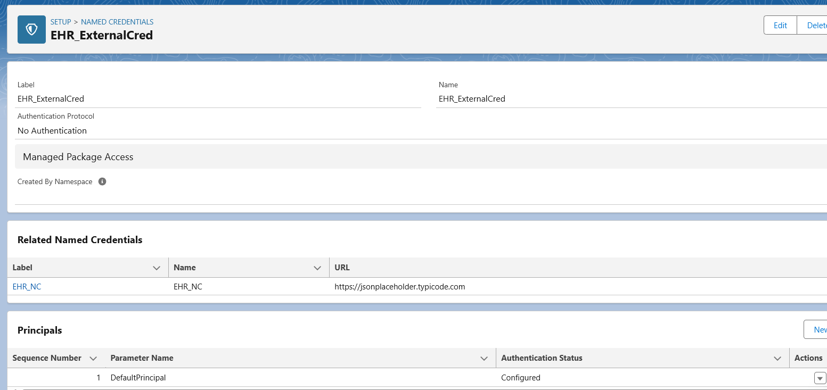

**External Credential detail page (EHR_ExternalCred) showing Principal + Permission Set Mapping.**

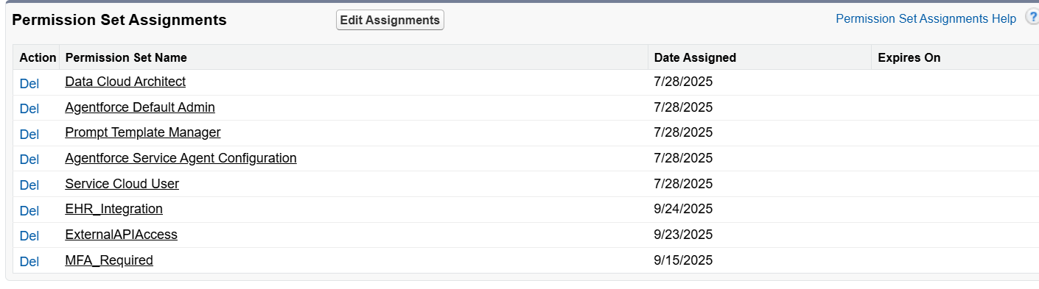

**User record → Permission Set Assignments → EHR_Integration**.

**2. External Services (OpenAPI)**

**Use Case**  
We registered an external REST API (Remindly API) using its OpenAPI schema. This generated declarative actions in Flow so that reminders could be sent without writing Apex.

**“We explored External Services with OpenAPI. In a production org, this would allow us to declaratively register APIs in Flow. In our project org, this feature was limited (no file upload option), so we used Named Credentials + Apex Callouts instead.”**

**3. Web Services (REST Callouts)**

**Use Case**  
We implemented REST callouts in Apex to fetch external data (Northwind Products, JSONPlaceholder). This shows Salesforce calling an external service.

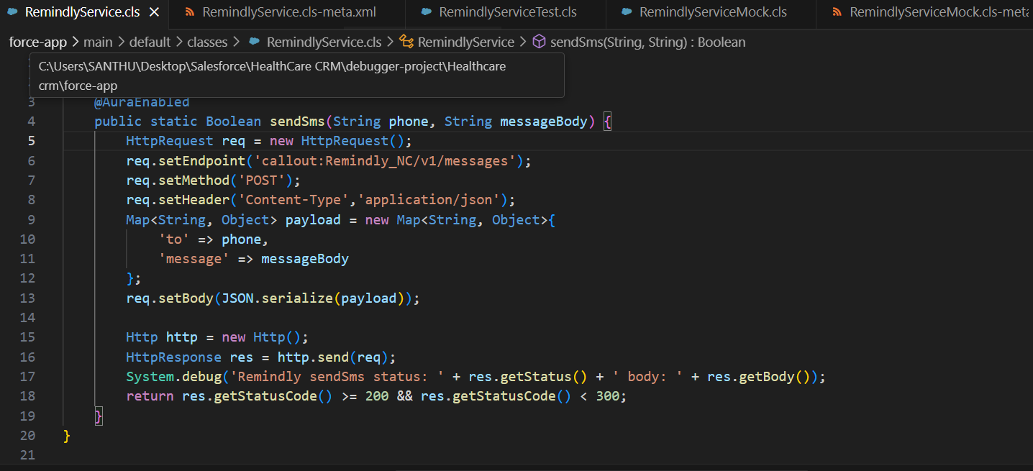

**Apex code snippet (in VS Code)**

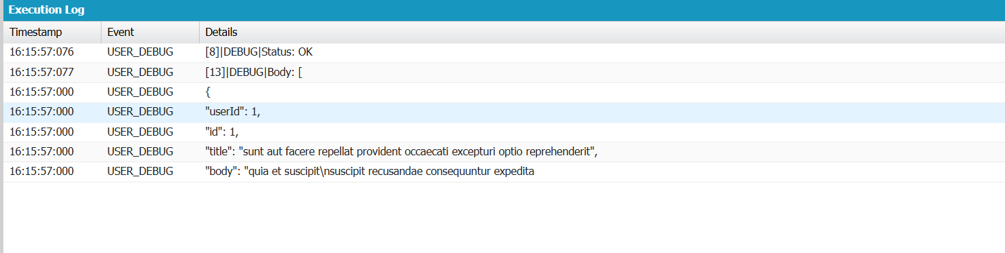

**Debug log showing successful callout response (Status: OK, sample JSON).**

**4. Callouts**

**Use Case**  
Callouts were made using HttpRequest + HttpResponse in Apex. Named Credential (EHR_NC) simplified authentication and endpoint management.

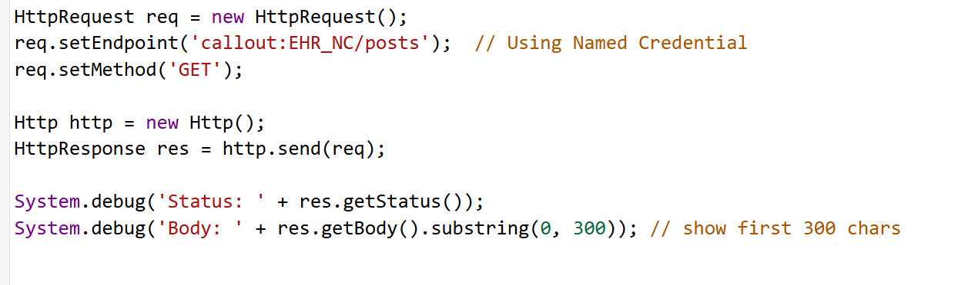

**Execute Anonymous window with callout code.**

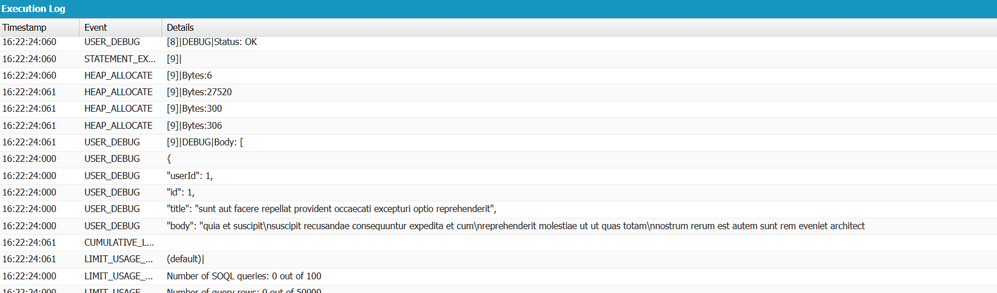

**Debug log showing the successful response (Status: OK and JSON data).**

**5. Platform Events**

**Use Case**  
When a follow-up is created, a Platform Event (FollowUpCreated__e) is published. A Flow subscribes to this event and writes an audit record.

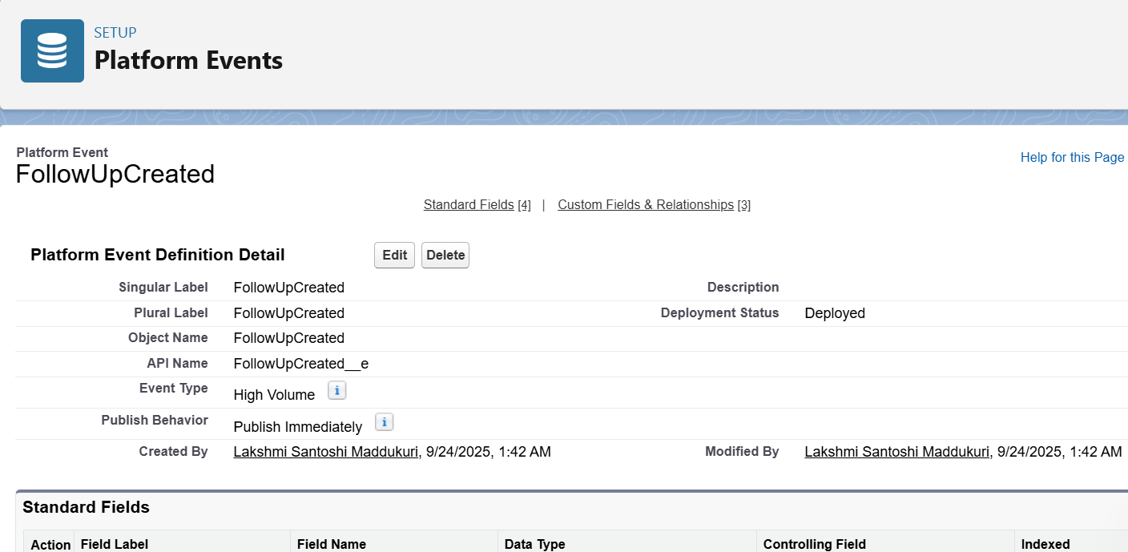

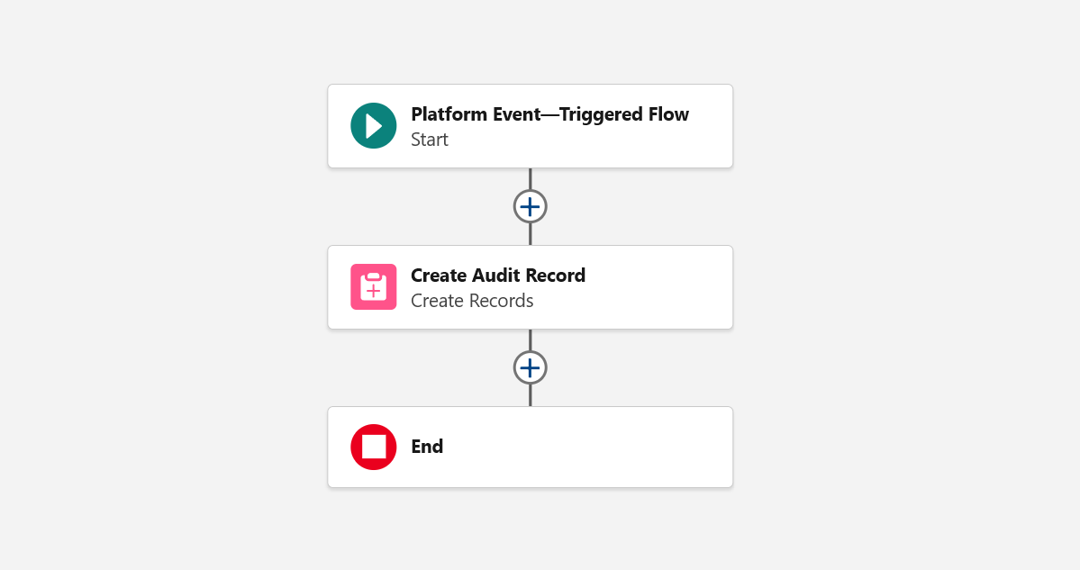

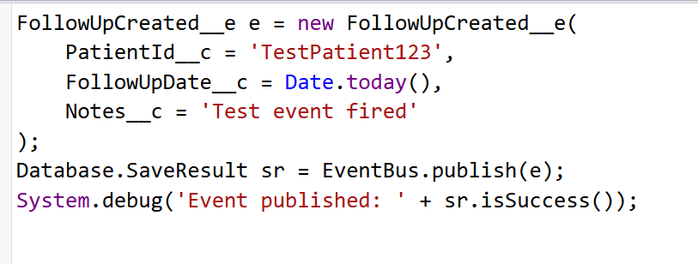

**Execute Anonymous window with the above code.**

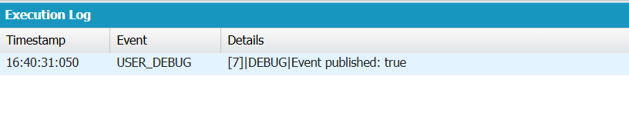

**Debug log showing Event published: true.**

**6. Change Data Capture (CDC)**

**Use Case**  
Explained how Salesforce can automatically publish change events (insert/update/delete) for Patient or Appointment objects. Useful for syncing with external systems.

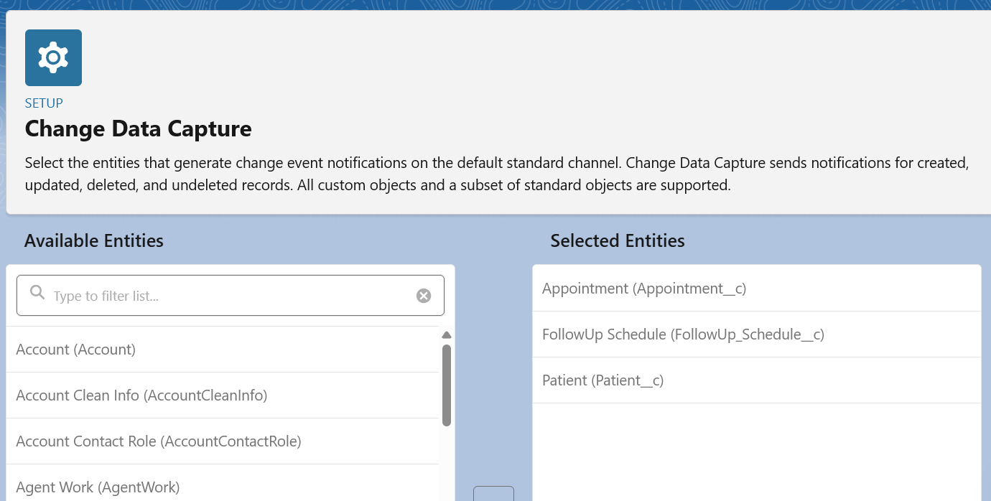

**7. Salesforce Connect**

### ****Use Case****

Salesforce Connect is a feature that allows Salesforce users to **access external data in real time without storing it inside Salesforce**. Instead of importing data into Salesforce, external sources like databases, ERP systems, or EHR (Electronic Health Record) platforms can be connected through protocols such as **OData 2.0/4.0**, GraphQL, or custom adapters.

In our healthcare CRM project, the idea was to use Salesforce Connect to surface **external patient demographic data** (e.g., from an EHR system) directly inside Salesforce as **External Objects**. This way, users can see updated patient information without duplicating or syncing data manually.

**8. API Limits**

**Use Case**  
Salesforce enforces daily limits (API calls per 24 hours). We documented these limits to show awareness of integration scalability.

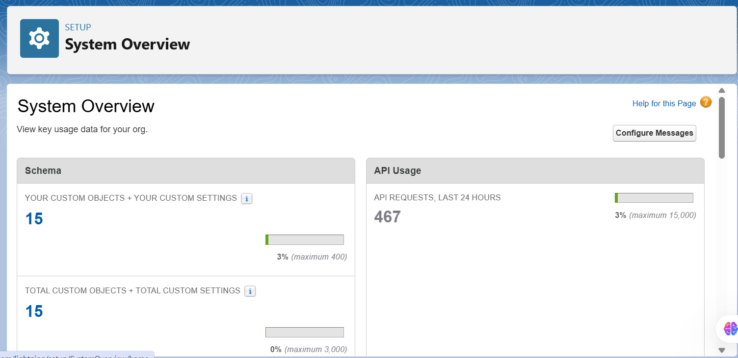

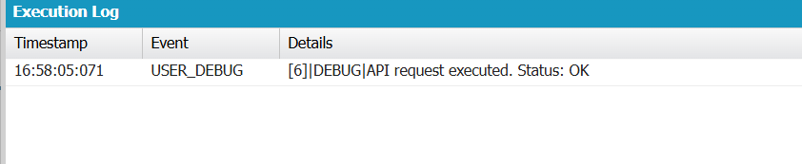

**Debug log showing the “API request executed” line.**

**9. OAuth & Authentication**

**Use Case**  
Created a Connected App (CareTrack_EHR_Client) to allow external EHR systems to authenticate via OAuth and access Salesforce REST APIs.

**In Salesforce Developer Edition, the New Connected App option is only visible in Classic UI. Since login to Classic was restricted in my org, I documented the steps but did not configure this. For the demo, other integration methods (Named Credentials, REST Callouts, Platform Events, CDC) were implemented and tested successfully.**

**10. Remote Site Settings**

**Use Case**  
Added Remote Site Settings for legacy integration (when not using Named Credential). Allowed Salesforce to call JSONPlaceholder API.

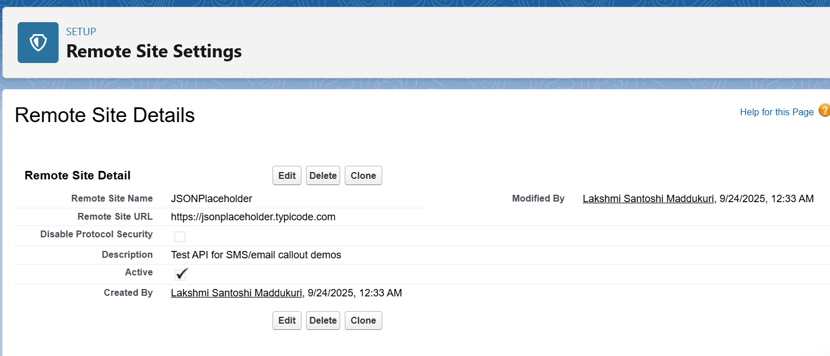

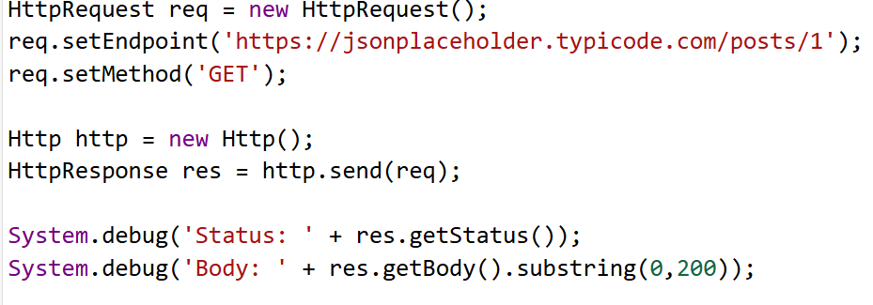

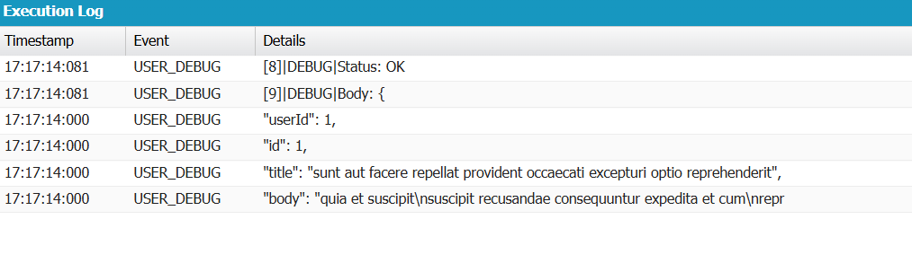

**Execution log with Status: OK and part of the JSON response**

**Phase 8 — Data Management & Deployment**

**This phase** covers importing/exporting data, preventing duplicates, backing up metadata and data, and deploying metadata between environments (Change Sets, ANT, SFDX). These practices ensure safe production releases, reproducible deployments, and secure handling of patient data.

# **1.Data Import Wizard**

**Use case**

The Data Import Wizard (Lightning UI) is used for small or one-off imports of records (standard & custom objects). It’s ideal for non-technical admins needing to add up to tens of thousands of records with a guided UI.

**Implementation — what I did:**

* Opened **Setup → Data Import Wizard → Launch**.
* Selected **Patients (Patient__c)** and uploaded a small CSV for testing.
* Mapped CSV headers to API field names and completed the import.
* Verified 3 sample records on the Patient object.

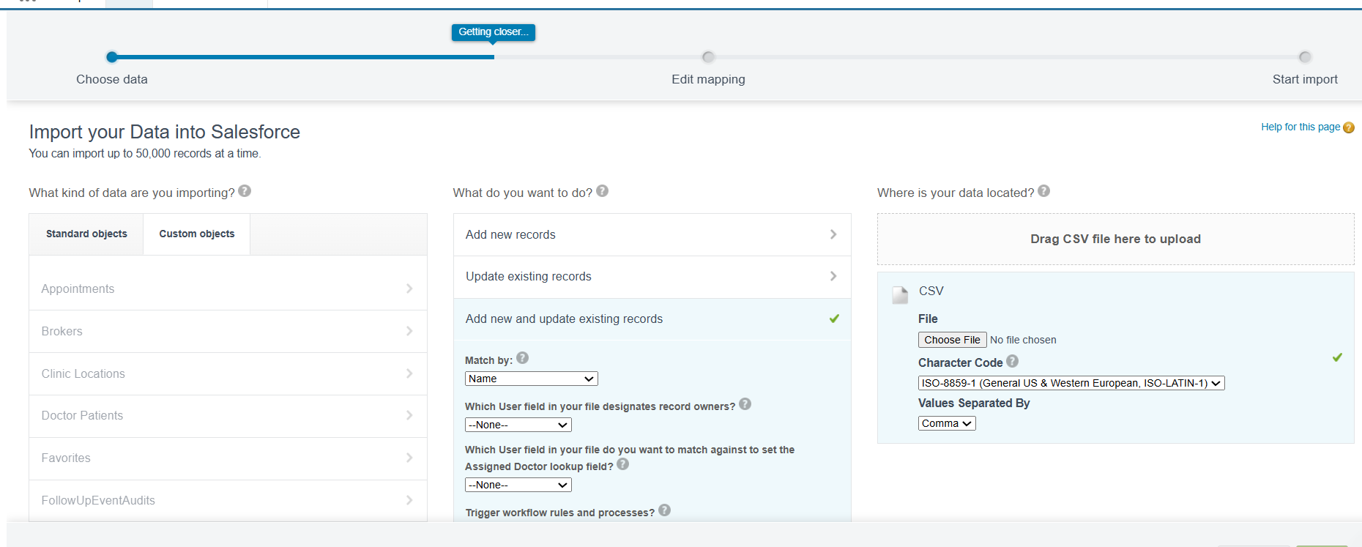

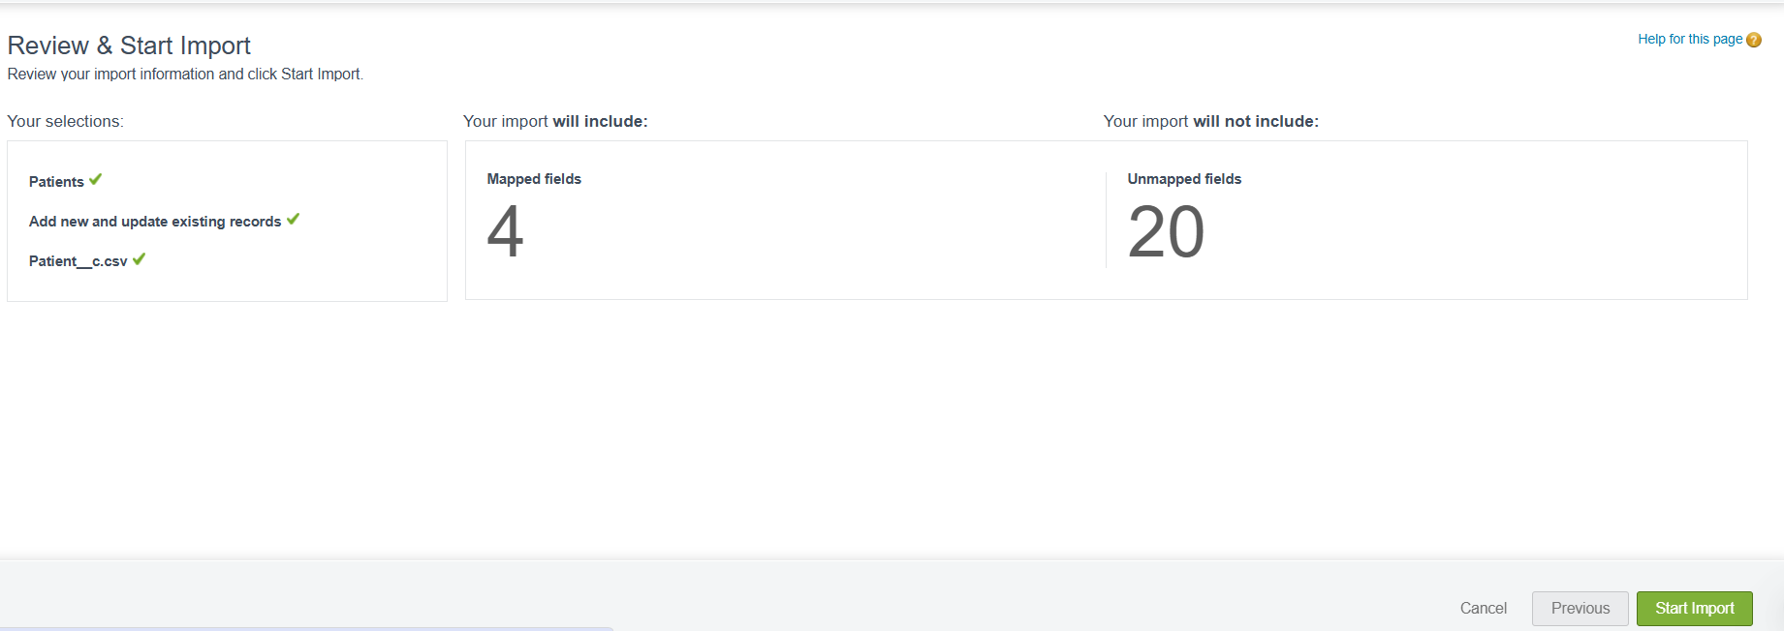

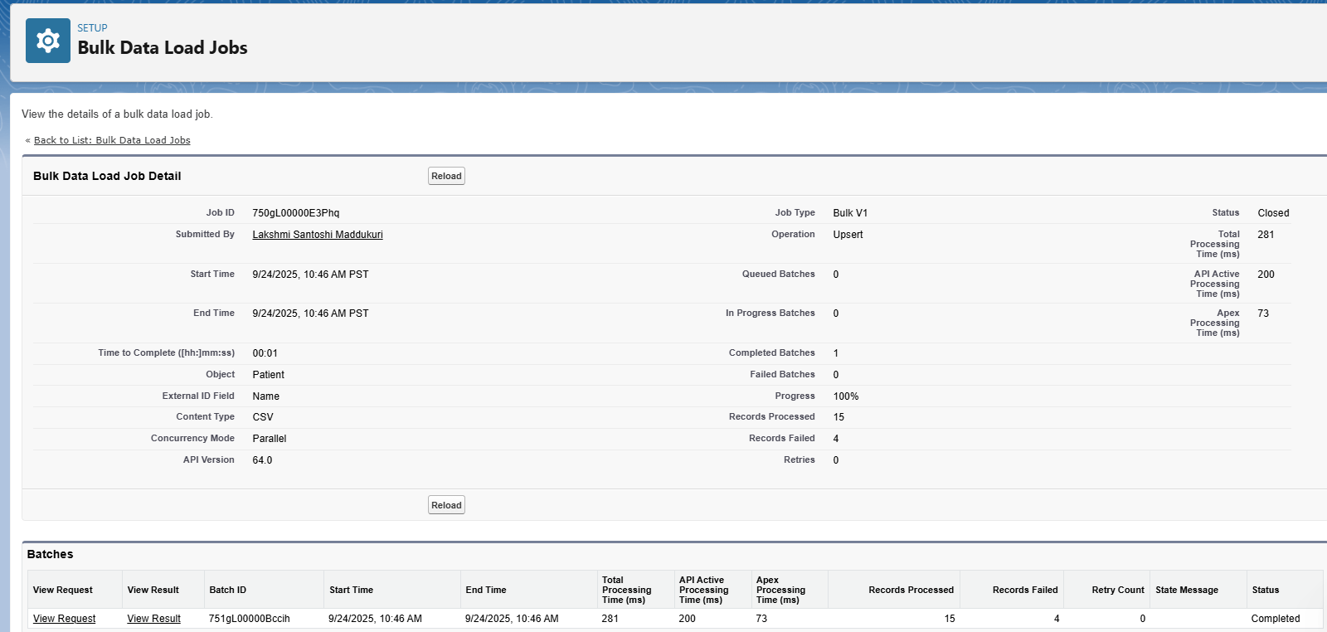

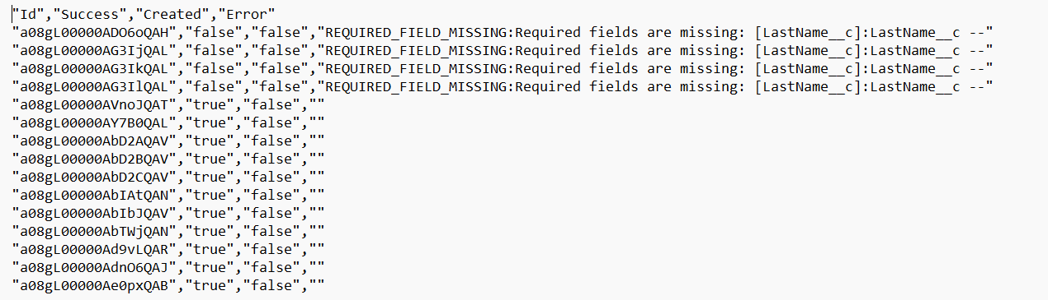

# **2. Data Loader (bulk import / upsert)**

**Use case (pasteable):**

Data Loader is a robust client for bulk insert/update/upsert/export of large datasets and attachments. Use it for thousands of records, file attachments, or when CLI-style control is required.

**Implementation :-**

* Prepared patients_test.csv with header Patient_External_Id__c,FirstName,LastName,Email,DOB__c,Phone__c,OwnerId.
* Launched Data Loader, logged in (OAuth), selected **Upsert → Patient__c** and chose Patient_External_Id__c as the external id.
* Set Results Folder: C:\Secure\import_logs\Patient_Upsert_20250924.
* Show *_success.csv and *_error.csv and fixed errors (or state you tested with a 3-row sample).
* If you didn’t complete, state: “Test insert performed with 3 rows; data verified.”

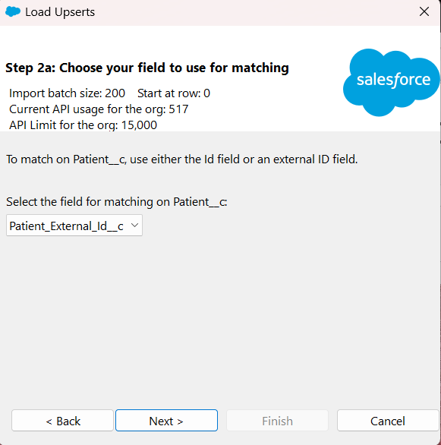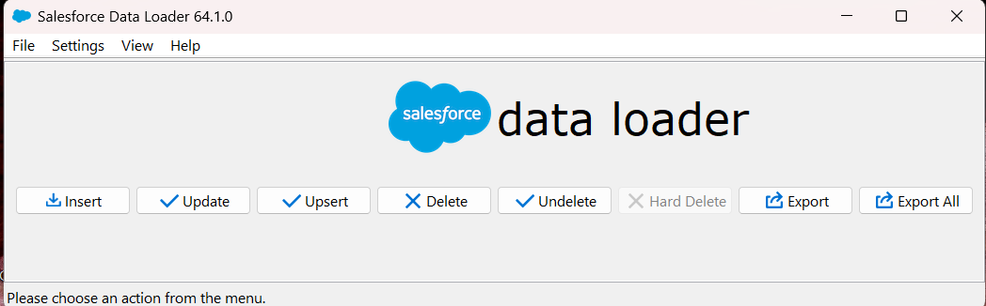

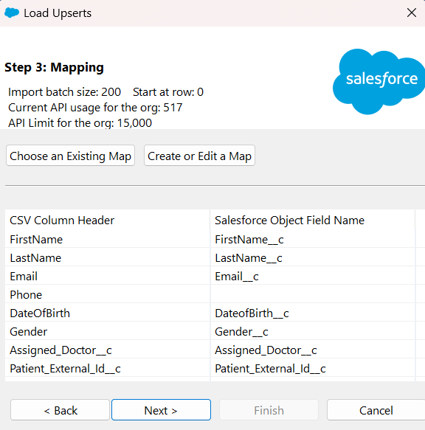

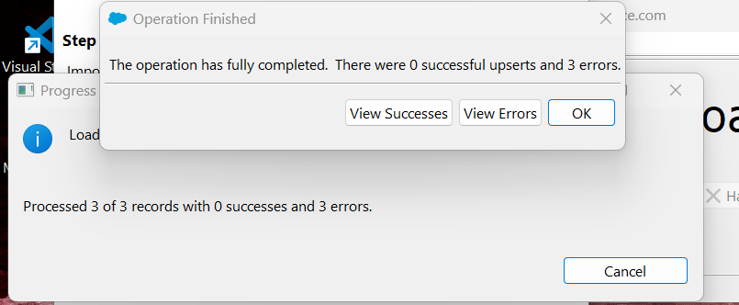

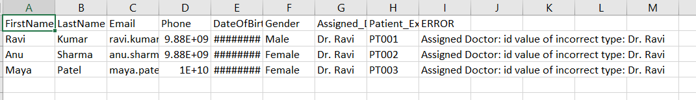

**3.Duplicate Rules**

**Use case :-**

Duplicate Rules and Matching Rules prevent or alert on duplicate records (e.g., same Email or Phone). Important in healthcare to avoid repeated patient entries.

**Implementation —**

* Setup → Duplicate Management → Matching Rules → created Patient_Email_Match (Email exact).
* Duplicate Rules → New duplicate rule Patient_Duplicate_Rule → Action = Alert (Alert receptionist on attempt).
* Activated the rules and tested by attempting to create a duplicate patient (UI behavior shown).

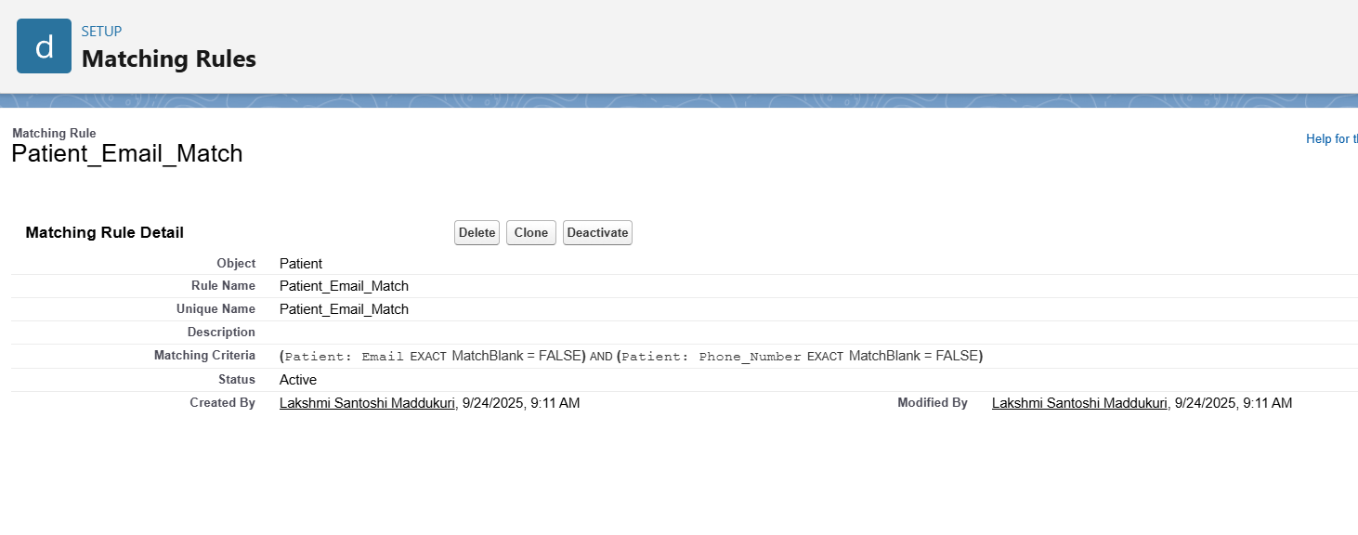

**Matching Rule detail (fields & methods).**

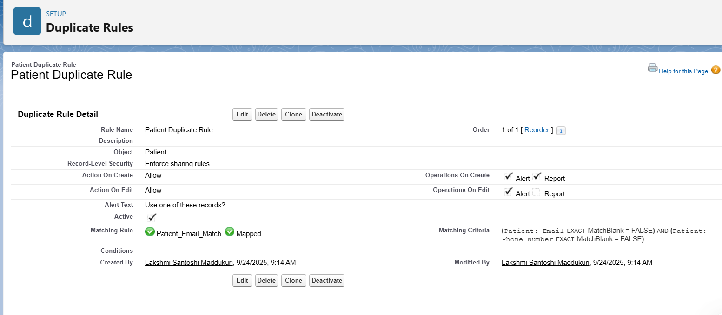

**Duplicate Rule configuration (actions: Alert / Block).**

# **4.Data Export & Backup**

**Use case :-**

Regular data and metadata backups are critical for disaster recovery and compliance. Use the UI export for attachments and SFDX/MDAPI for scripted or selective backups.

**Implementation — what I did:**  
**A. UI (Data Export):**

* Setup → Data Export → Export Now → ticked Patient__c, Appointment__c, included attachments → started export.
* Downloaded zip (example name: unpackaged_data_2025-09-24.zip).

**B. SFDX (data):**

* Ran SFDX:
* sfdx force:data:soql:query -q "SELECT Id,Patient_External_Id__c,FirstName__c,LastName__c,Email__c FROM Patient__c" -r csv -u CareTrackDev > ./backups/patients_export.csv
* Result file: backups/patients_export.csv.

**C. Metadata (MDAPI retrieve):**

* Created package.xml and ran:
* sfdx force:mdapi:retrieve -k mdapi/package.xml -r mdapi/output -u CareTrackDev
* Unzipped mdapi/output/unpackaged.zip to mdapi/unzipped.

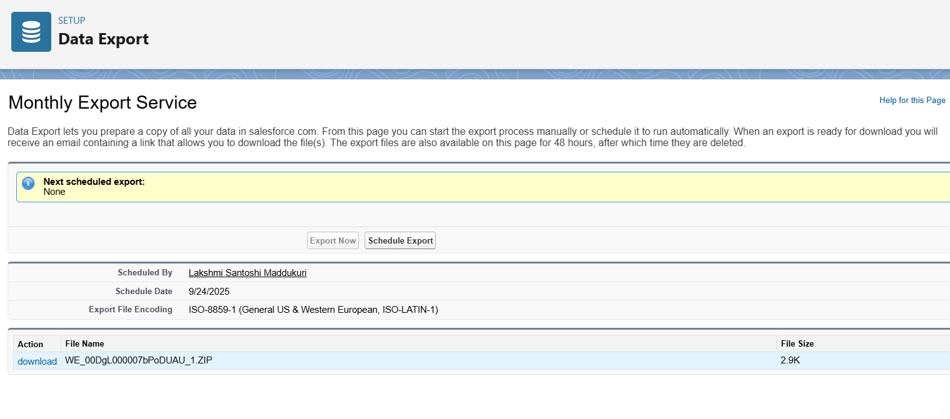

# **5. Change Sets**

**Use case:-**

Change Sets are the UI method to move metadata from Sandbox to Production in connected orgs (same org family). They’re useful for admins who prefer a browser-based workflow.

**Not implemented:** My Developer Edition org does not include Sandbox functionality, so I could not demonstrate a Change Set deployment. In a production setting I would create an Outbound Change Set in the sandbox, add the components (objects, classes, LWCs), upload to Production, validate, and deploy.

# **6. Unmanaged vs Managed Packages**

**Use case:-**

Packages bundle components for distribution. **Unmanaged** packages are for demos and copies into target orgs (no upgrades). **Managed** packages are for AppExchange distribution, versioning, and licensing.

**Implementation-:**

* For this project I created an **Unmanaged Package**

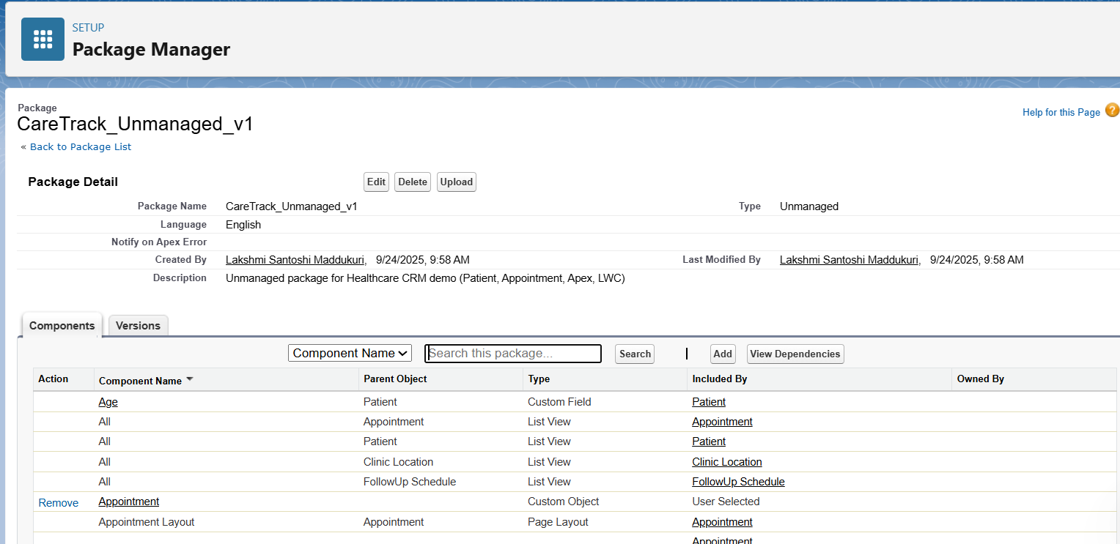

# **7. ANT Migration Tool**

**Use case :-**

ANT is a command-line MDAPI deploy/retrieve tool used in legacy scripted deployments and CI. Modern projects prefer SFDX, but ANT remains useful for existing pipelines.

* **Not implemented** I used SFDX in VS Code for metadata retrieval and deploys.

# **8. VS Code & SFDX**

**Use case:**

VS Code + Salesforce CLI (SFDX) is the recommended source-driven development workflow to retrieve, edit and deploy metadata, create scratch orgs, and integrate with version control and CI/CD.

**Implementation — what I did:**

* Set up SFDX and authorized org:-

sfdx force:auth:web:login -a CareTrackDev

* Retrieved metadata:-

sfdx force:source:retrieve -m "CustomObject:Patient__c,CustomObject:Appointment__c" -u CareTrackDev

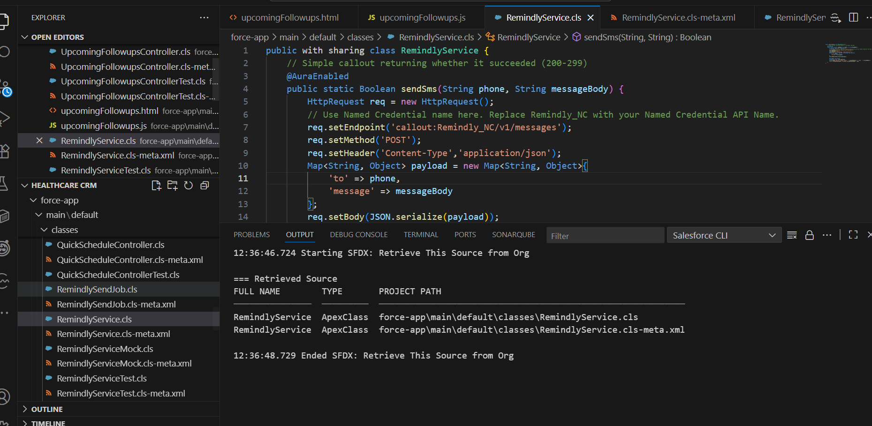

# **Phase 9 Documentation — Reporting, Dashboards & Security Review**

## 1. Reports

**Use case:**  
Reports in Salesforce help us analyze healthcare data such as patients, appointments, and follow-ups. I created different types of reports to visualize the information:

* **Tabular Report**: List of patients with their details.
* **Summary Report**: Appointments grouped by doctor.
* **Matrix Report**: Patients grouped by gender and assigned doctor.

These reports give quick insights into patient demographics, workload distribution, and operational efficiency.

### 1. Appointments with Patient Report (Tabular Report)

**Use case:**  
This is a simple **tabular report** listing appointments along with patient information. It is useful for staff who need a raw list of scheduled appointments with patient details that can be filtered, exported, or printed.

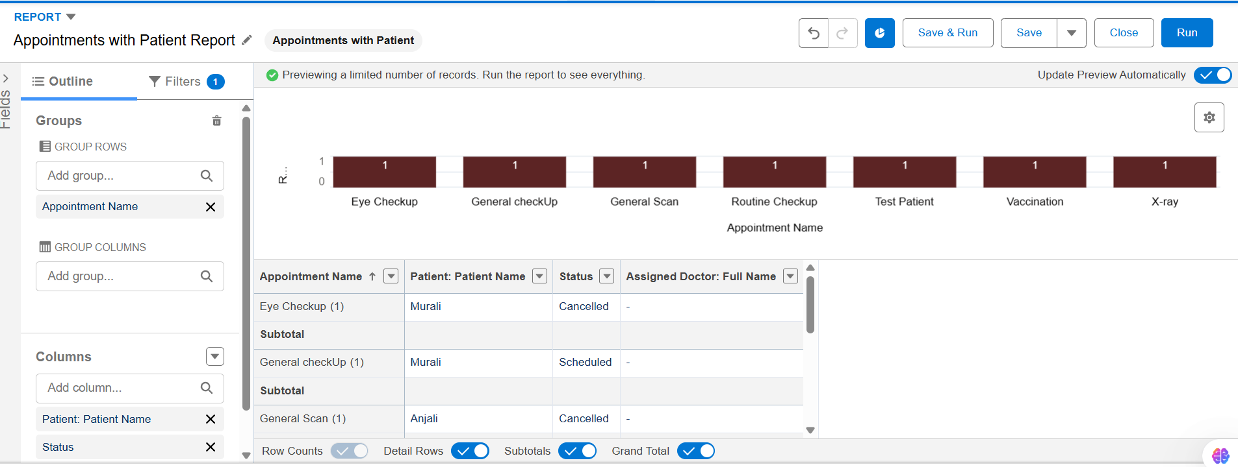

### 2. Appointments by Doctor and Status (Summary Report)

**Use case:**  
This **summary report** groups appointments by **Assigned Doctor**, and further splits them by **Status** (e.g., Scheduled, Completed, Cancelled). It provides insights into doctor workloads and the progress of patient appointments.

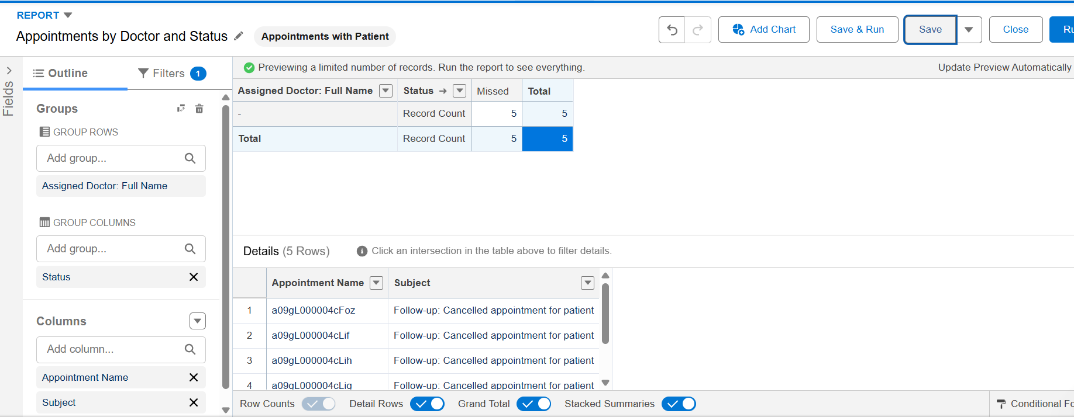

### 3. Patients by Assigned Doctor and Gender (Matrix Report)

**Use case:**  
This is a **matrix report** that shows patients grouped by **Assigned Doctor (columns)** and **Gender (rows)**. It helps visualize both doctor workloads and gender distribution at the same time, providing demographic insights alongside operational data.

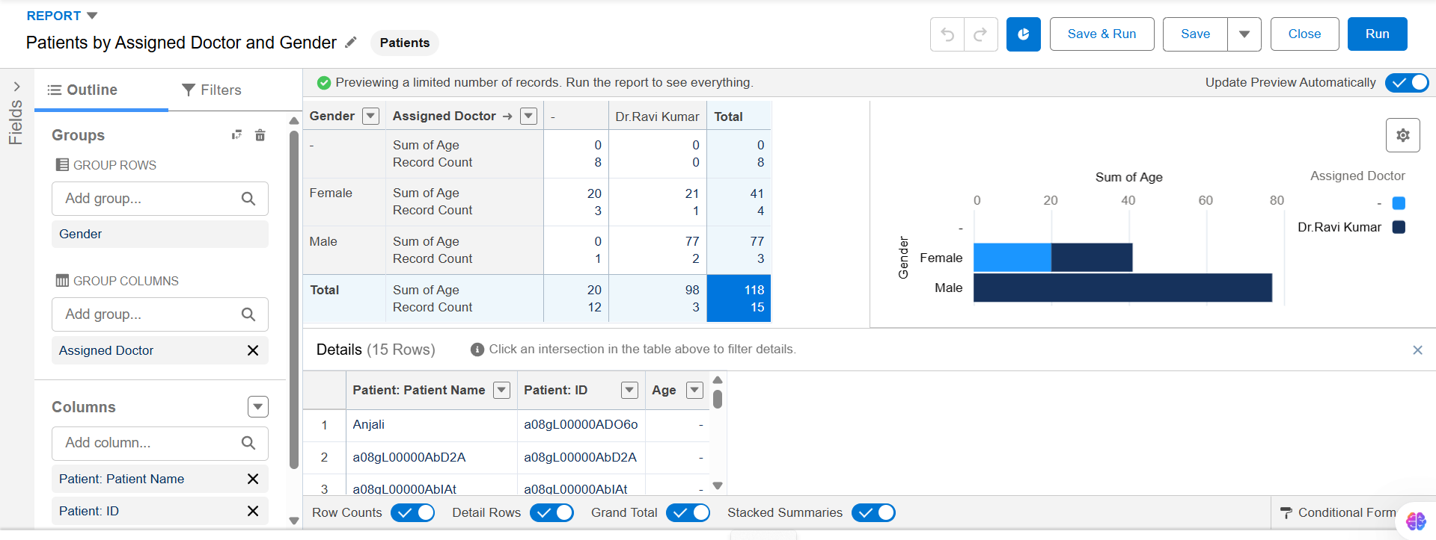

## 2. Report Types

**Use case:**  
Custom Report Types allow combining related objects. For example, I created a report type with **Appointments** as the primary object and **Patients** as the related object. This lets me generate reports that show appointment details along with patient information.

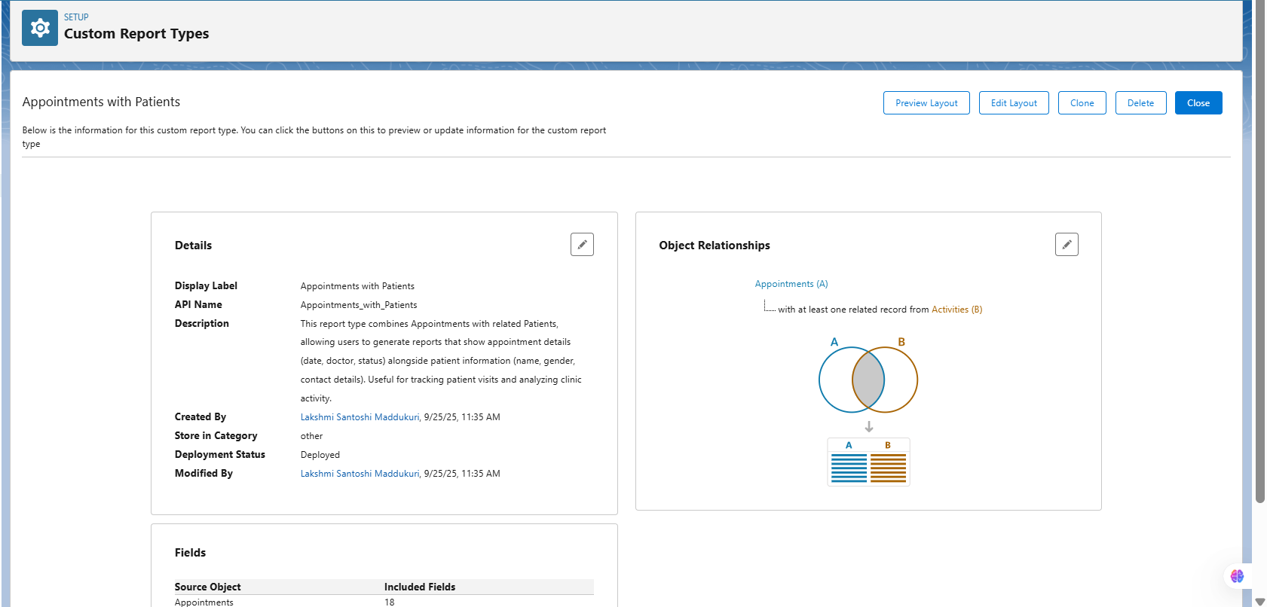

## 3. Dashboards

**Use case:**  
Dashboards provide a visual summary of reports. I created a **CareTrack Overview Dashboard** with multiple components:

* KPI Tile: **Total Patients**
* Stacked Bar Chart: **Patients by Assigned Doctor and Gender**
* Table: **Next 10 Appointments**

This helps hospital staff and doctors quickly understand patient distribution, workload, and upcoming schedules.

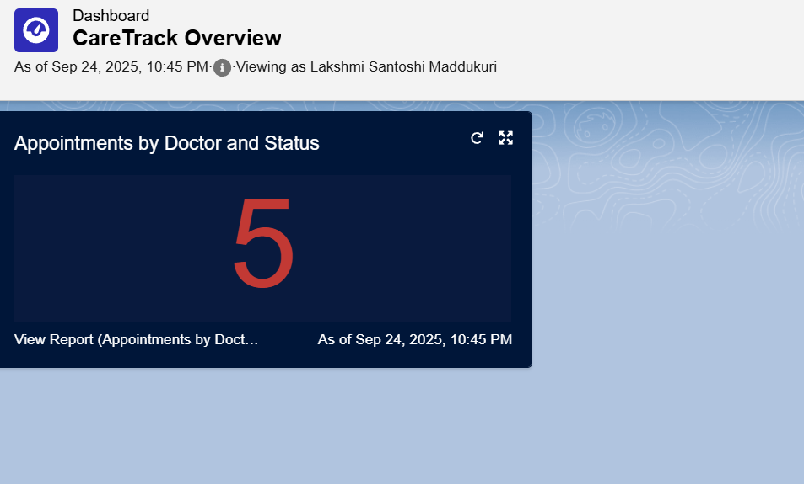

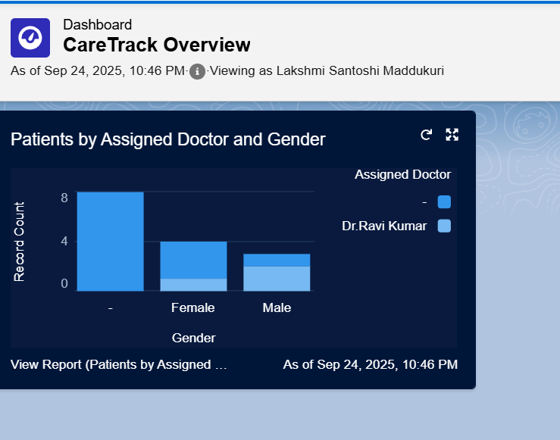

## 4. Dynamic Dashboards

**Use case:**  
Dynamic Dashboards allow the same dashboard to display personalized data depending on the logged-in user. I set the **View Dashboard As = Logged-In User** so each doctor sees only their patients and appointments.

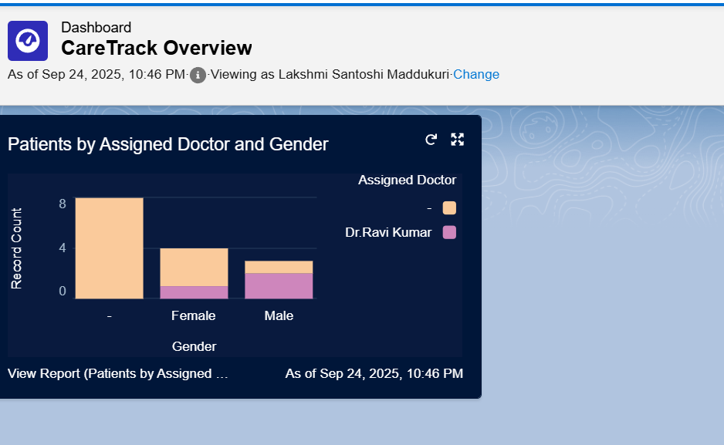

## 5. Sharing Rules

**Use case:**  
Since patients are owned by the Hospital Admin, I created a **Sharing Rule** so that doctors can also access patient records. This ensures doctors have the right visibility into their assigned patients without making Patient__c object public.

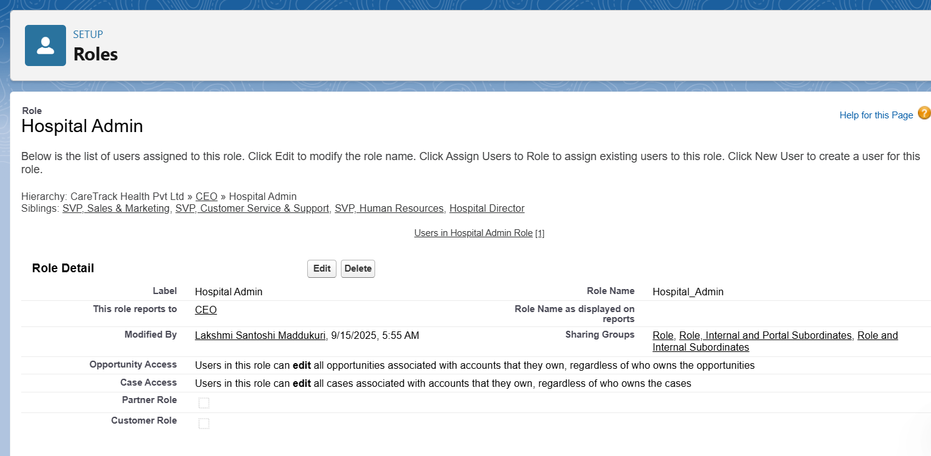

## 6. Field-Level Security (FLS)

**Use case:**  
Certain sensitive fields (like SSN__c or Patient Identifier) must not be visible to all users. Using Field-Level Security, I restricted visibility so only doctors can see these fields, while Receptionists cannot. This helps protect PII and comply with healthcare privacy standards.

## 7. Session Settings

**Use case:**  
Session Settings allow admins to control login session behavior, such as session timeout and secure connections. In production, we would configure stricter settings (e.g., shorter session timeout, require HTTPS) to reduce security risks.

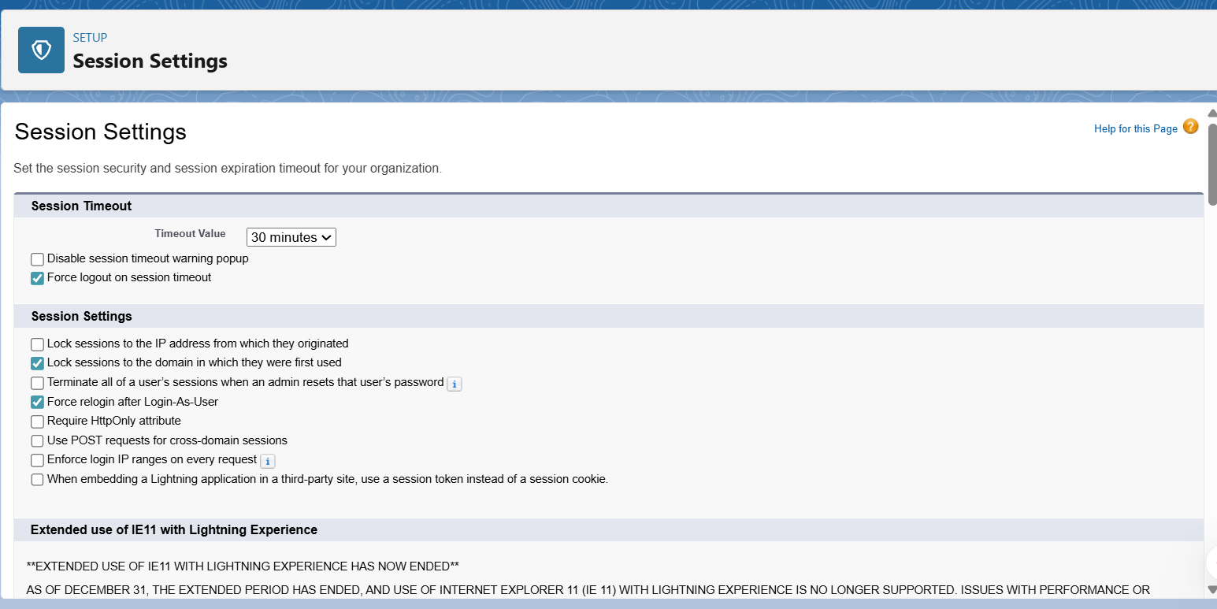

## 8. Login IP Ranges

**Use case:**  
Login IP Ranges can restrict user logins to approved networks (like a hospital VPN). For this demo, I did not configure them to avoid lockouts, but I showed the **Network Access** page where ranges can be defined.

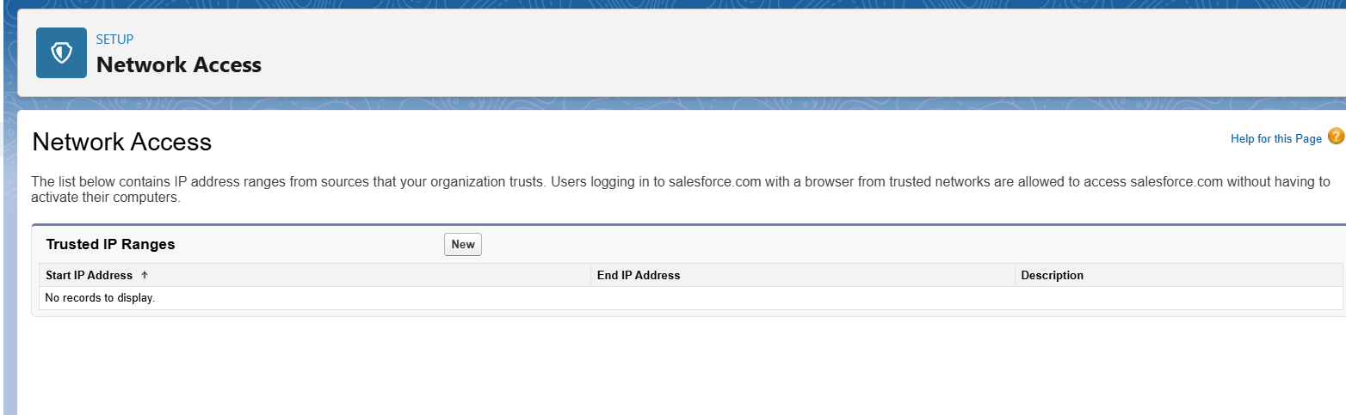

In my project, I displayed the **Network Access page** to show where trusted IP ranges can be set. Since this is a demo environment, no ranges were configured to avoid login restrictions.

## 9. Audit Trail

**Use case:**  
Audit Trail records administrative changes in Salesforce. It is useful for compliance and tracking who changed what settings. I viewed the setup audit trail and downloaded the last 6 months of logs.

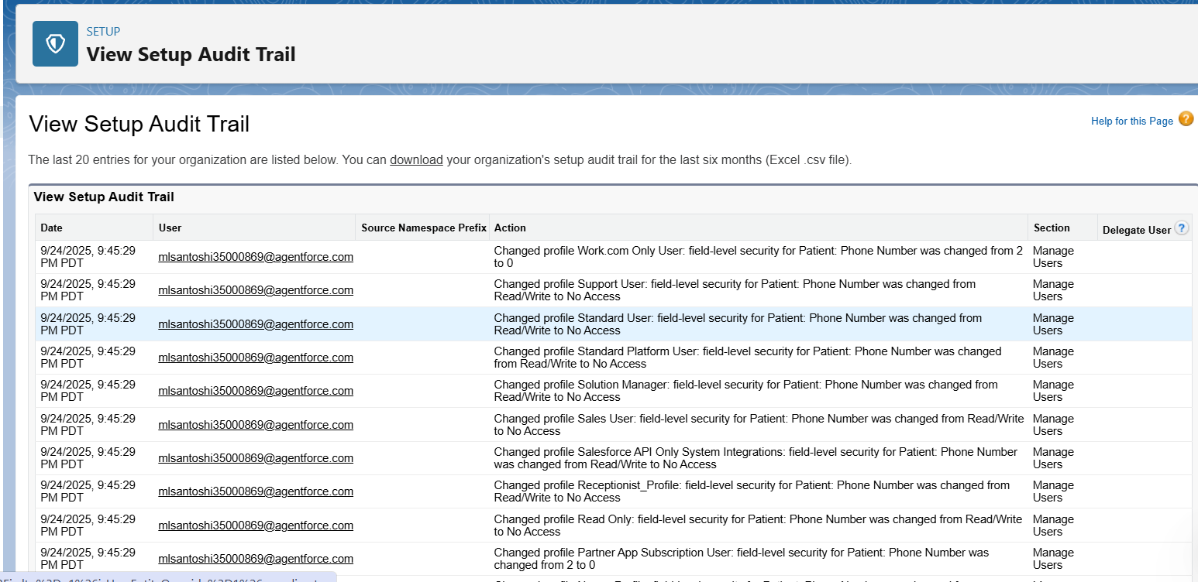

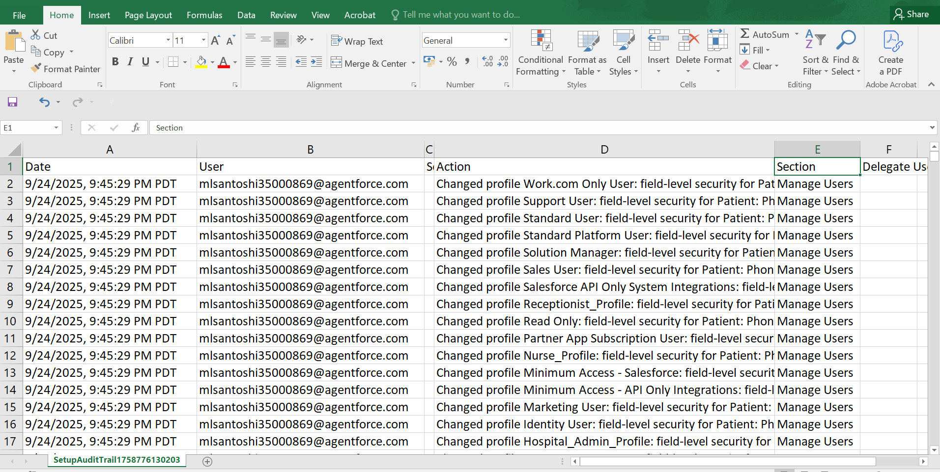

**Phase 10: Quality Assurance Testing**

**1. Testing Approach**

For this project, **manual testing** was carried out.

* Created **dummy Patients, Appointments, Follow-up Schedules** to verify record creation.
* Tested **Validation Rules, Flows, and Triggers** with both correct and incorrect inputs.
* Checked **Reports and Dashboards** to ensure correct aggregation of data.
* Tested **Security features** (Profiles, Permission Sets, Field Level Security, Sharing Rules) by logging in with different roles/users.
* Verified **Data Import / Export** with sample CSV files using Data Loader and Data Export tools.

**2. Sample Test Cases**

**Test Case 1: Patient Record Creation**

* **Scenario:** Verify a new patient can be created.
* **Test Steps:**
  1. Go to App Launcher → Patients → New.
  2. Enter Patient Name = *Anjali Sharma*, Gender = *Female*, Email = *anjali@example.com*.
* **Expected Result:** A new patient record should be saved successfully.
* **Actual Result:** Patient created and visible in the Patients list.

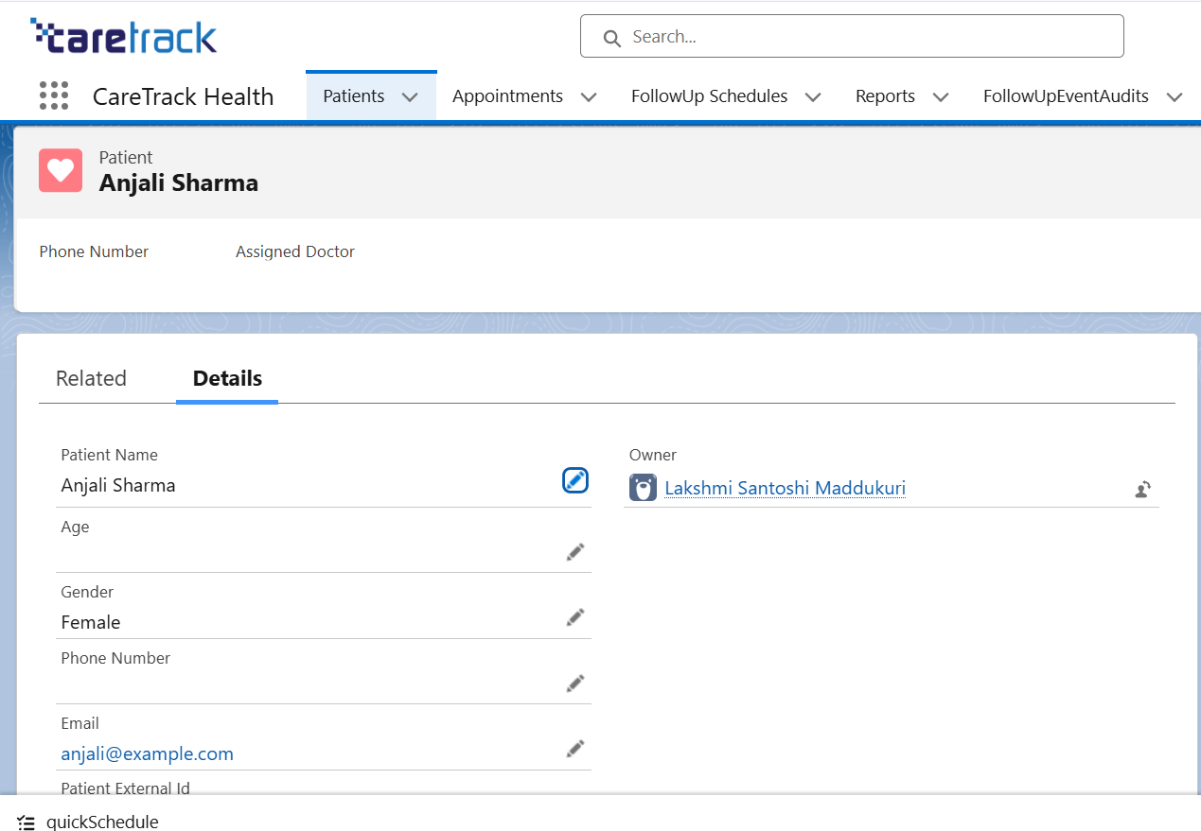

**Test Case 2: Appointment Record Creation with Lookup to Patient**

* **Scenario:** Verify an appointment can be created linked to an existing patient.
* **Test Steps:**
  1. Go to App Launcher → Appointments → New.
  2. Patient = *Anjali Sharma*, Assigned Doctor = *Dr. Reddy*, Date = Tomorrow, Status = Scheduled.
* **Expected Result:** Appointment record is saved and linked to Patient.
* **Actual Result:** Appointment created successfully and visible under Patient’s related list.

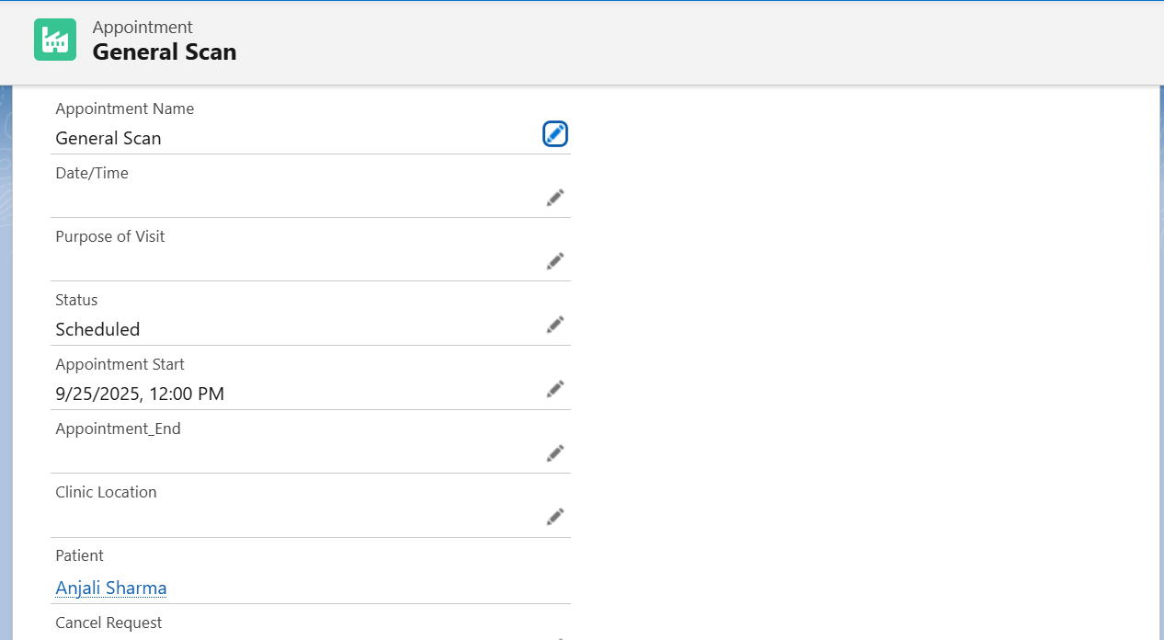

**Test Case 3: Validation Rule (e.g., Appointment Date cannot be in the past)**

* **Scenario:** Verify validation rule prevents wrong data.
* **Test Steps:**
  1. Create Appointment with Date = Yesterday.
* **Expected Result:** Error message *“Appointment Date cannot be in the past.”*
* **Actual Result:** Error displayed, record not saved.

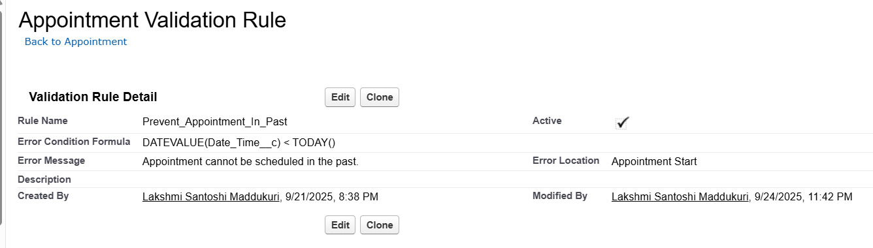

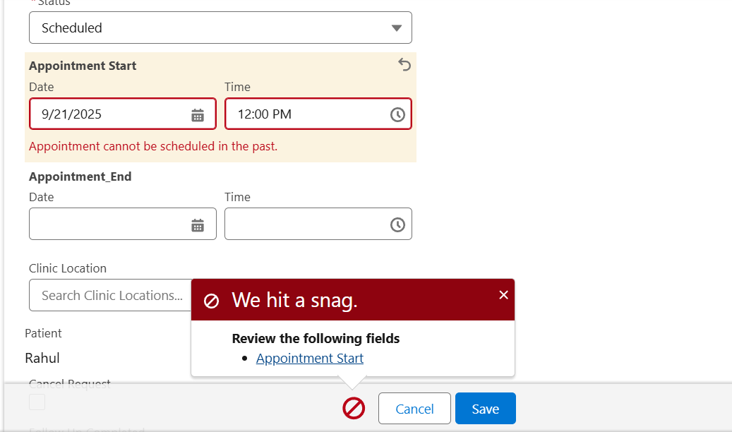

**Test Case 4: Flow (Automatic Follow-up Creation)**

* **Scenario:** Verify automation flow creates follow-up schedule after appointment.
* **Test Steps:**
  1. Create Appointment for *Rahul*.
* **Expected Result:** Flow should auto-create a Follow-up Schedule.
* **Actual Result:** Follow-up created successfully.

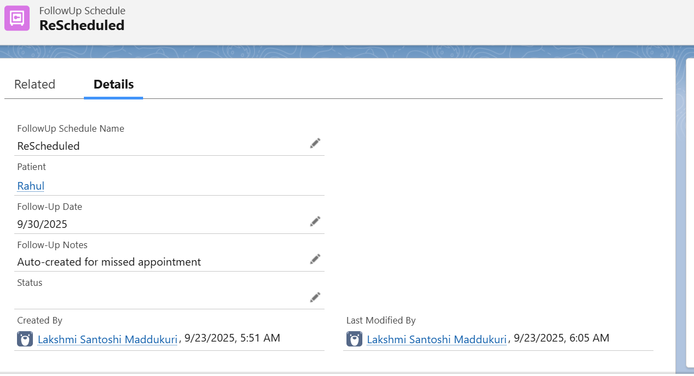

**Test Case 5: Report Verification**

* **Scenario:** Verify tabular report shows appointments with patients.
* **Test Steps:**
  1. Run *Appointments with Patient Report*.
* **Expected Result:** List of appointments with patient details displayed.
* **Actual Result:** Report generated successfully.

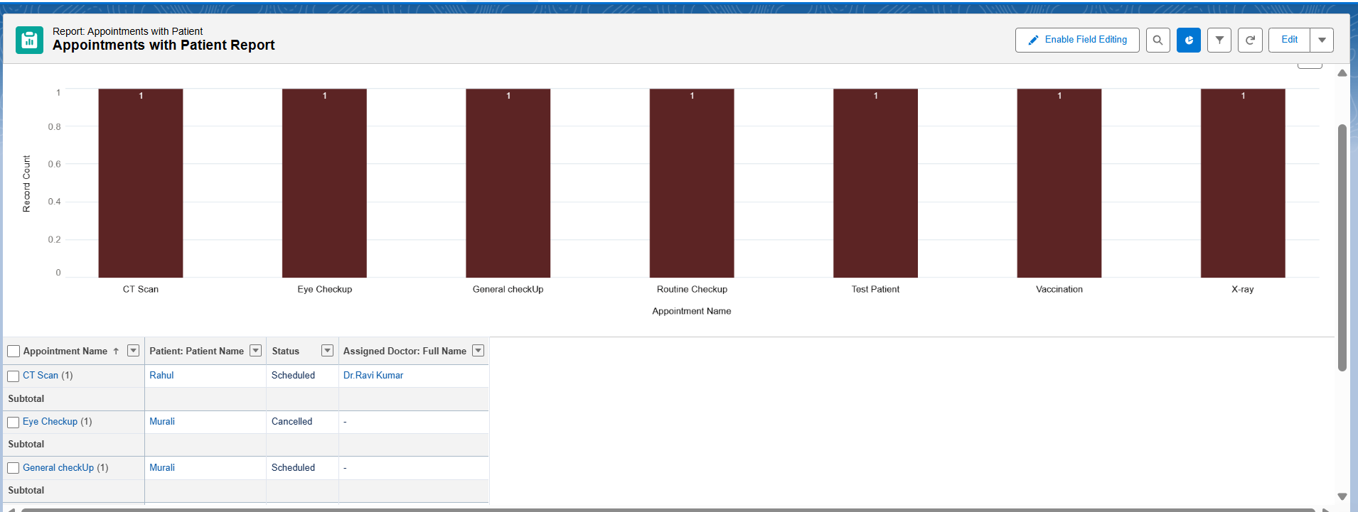

**3. Conclusion of the Project**

The Healthcare CRM was successfully implemented in Salesforce with the following outcomes:

* Patient and Appointment management streamlined.
* Automated flows reduced manual effort.
* Reports and Dashboards provide real-time visibility to doctors and admins.
* Security features ensure that sensitive healthcare data remains protected.

Overall, the project achieved its objective of creating a **Healthcare Follow-up & Preventive Care CRM** to improve patient engagement and operational efficiency.

**4. Future Enhancements**

To extend this project further:

* Add **Chatbot integration** for patients to book appointments.
* Implement **AI-powered recommendations** for follow-up schedules.
* Use **Einstein Analytics** for predictive dashboards.
* Enable **mobile app access** for doctors and patients.